A Strategy and an Alternative to the Ethics and Member Conduct Committee, the EMCC, Providing Full IEEE Ethical Advice and Support in Employee-Employer Disputes
Walter L. Elden, P.E. (Ret)
IEEE and SSIT Life Senior Member
w.elden@ieee.org
January 24, 2016

INTRODUCTION

I intend for this to be my final contribution to the IEEE TAB/SSIT Ethics Task Force, established to look into IEEE’s ethics history and gaps needing to be fixed. Previously, I have written several papers (1, 2, 3, 4) proposing for the IEEE Ethics and Member Conduct Committee, the EMCC, to have its original purpose of offering ethical advice and support to Members, reinstated by the IEEE Board. This was argued needed to be done since the Board formally adopted such restrictions and placed them in the EMCC Operations Manual (5) in 2005 prohibiting these services from its own Members. I now see there is an alternative; one which should be easier and hopefully a quicker way to achieve the goal for IEEE Members to have access to ethical advice and support. This paper presents that alternative.

IEEE Ethics Advice and Support Restrictions on the EMCC Background

The Technical Activities Board, TAB, of IEEE, at its November 2015 meeting, assigned the SSIT to form a Task Force to review IEEE’s history in ethics and to identify any gaps needing fixed, and to make an initial set of recommendations to it at its February Meeting.

In review, the IEEE began around 2000, informally at first restricting the EMCC from offering ethical advice and support to Members. Then, in 2005, it adopted its formal restriction (1), which I have concluded violates the IEEE Governance Documents, including its Code of Ethics (article 10), and the New York State law covering Not for Profit Corporations and the responsibilities their Directors have towards their Members (1). Today, it would be possible for this restriction to be removed, but that would require the IEEE Board of Directors to decide and to do that. To achieve that goal, however, is viewed to be a very difficult undertaking. But there is another, seemingly more straight forward way to accomplish the goal and the TAB/SSIT Task Force is being asked in this paper to consider this alternative approach.

I have written about this alternative in private emails to Greg Adamson, President of the IEEE Society on the Social Implications of Technology, the SSIT, copying both Drs Stephen Unger, SSIT Member and former IEEE Ethics Chair, and Charles Turner, Past EMCC Chair. So here is my proposed alternative and a Strategy for achieving the goal to restore ethical advice and support to Members.

A Strategy is Proposed for Restoring IEEE’s Ethics Advice and Support Services in Dispute Conflicts

Now that the Technical Activities Board, the TAB, took the leadership role to have a SSIT led Task Force look into IEEE’s history of ethics involvement and to identify gaps needing fixed this places TAB in a great position to do something sooner and hopefully easier than the full IEEE Board would do. Here is how.

First, the TAB/SIT Task Force should recognize that already under TAB is a Committee, called the Conflict Resolution Committee, the TAB CRC, and has within its charter already the handling of ethics conflict matters. Now to just modify its current established charter to add a few more services, could through this avenue, achieve what has been denied the Members now for over 15 years, ethical advice and support. Once the TAB would accept increasing the scope of its own CRC, then it, TAB, being a major component of IEEE that includes all programs of its 45 IEEE Societies and Technical Councils as well as programs of the Technical Activities Board (TAB) and the Technical Activities Department (TAD), would be in the position to exert considerable pressure on the full IEEE Board to correct these restrictions placed on its own EMCC. The following provides the content of the emails I wrote, proposing using the TAB CRC instead of the EMCC, to achieve the two stated goals.

My Proposal to Use the TAB CRC as an Alternative to the EMCC

As I studied the current charter of IEEE Ethics and Member Conduct Committee, the EMCC, which I helped establish its forerunner, the Member Conduct Committee in 1978 (6), I concluded that what is missing today in IEEE to be the following:

1. The EMCC is prohibited from giving ethical advice to Members

2. The EMCC is prohibited from getting involved in employee-employer ethical disputes

Then one day, recently, it occurred to me, upon examining the full scope of what the TAB Organizational Unit, or OU, was all about, I came across a committee called the Conflict Resolution Committee, or what I will refer to as the TAB CRC. I found that in its existing charter was contained the seeds of the two desired services, currently denied the EMCC to provide, of what could become ethical advice and support. Here is what I found and I propose to be expanded:

Charter of the TAB Conflict Resolution Committee, the TAB CRC

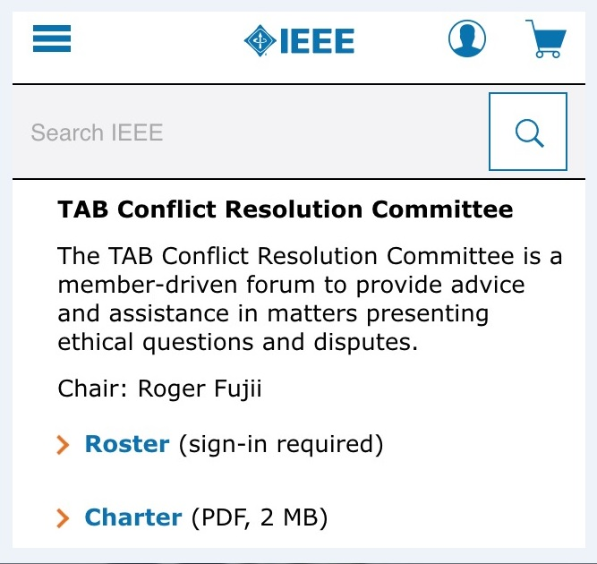

It seems to me that TAB's Conflict Resolution Committee could be expanded, formalized more, and assigned to the SSIT to lead, resulting in TAB, the major OU in IEEE, being in a great position to provide the desired services directly to Members, as long as the EMCC continues to be restricted from doing likewise . Besides, it already exists under TAB and is empowered to offer both ethics advice and assistance (support), whereas the IEEE Boards have for 15 years forbidden the EMCC from doing both.

Here is What the Full Current Charter of TAB’s Conflict Resolution Committee is Today

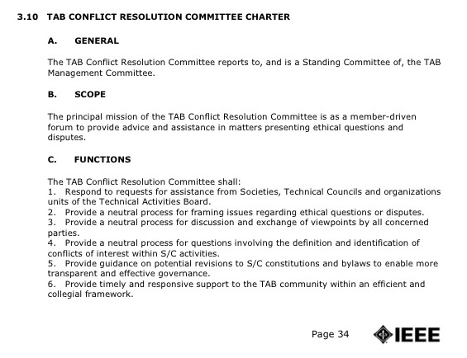

-Continued-
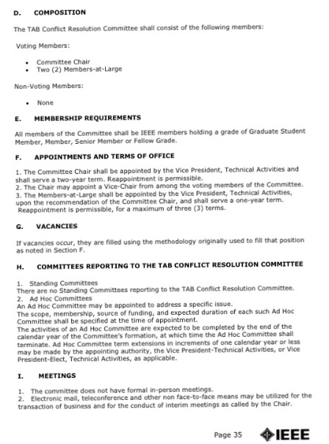
-continued-

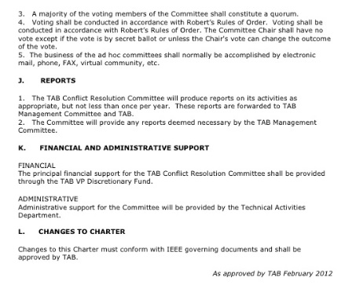
Martha Sloan’s 1998 Proposed Ethics Conflict Resolution Service, the ECRS
Coincidently, the TAB CRC’s name, Conflict Resolution Committee, is nearly the same as the service former IEEE PRESIDENT and MCC CHAIR Martha Sloan (7) first proposed in 1998, when I served on the MCC with her. At the time it was called the Ethics Conflict Resolution Service, or ECRS (8). At the same time, Wally Read, an additional former IEEE President and a member of the MCC, expressed his opposition to it when he said to the committee, that “he did not believe the IEEE should get involved in employee-employer conflicts” (1).

After that, her proposed Ethics Conflict Resolution Service was never presented to the Board for consideration. But Wally Read’s view, then expressed to the MCC of what he believed the proper role of the IEEE was to not be, became the policy of the IEEE Board informally starting around 2000, then formally in 2005, when the EMCC was restricted from advising and supporting Members ethically, as discussed above (5). In my opinion, this position violates article 10 of the IEEE Code of Ethics, among other IEEE Governance documents, wherein all IEEE Members (including Board of Director Members) agree to support other Members adhere to the Code of Ethics. Their 15 year restriction on the EMCC denies all Members this support.

Historically, I, having served as Martha’s Editor with her on the 1998 MCC for developing the proposal for her ECRS, fortunately remembered and later saved what were the basic set of services, in Martha's proposal (8). When she first proposed her Ethics Conflict Resolution Service to the MCC, I immediately saw and embraced the merits of it, and had an entirely different view of IEEE’s role of ethics and Member support than did Wally Read, but he had much more influence over events in IEEE than I did. Today, I continue to support its adoption and full implementation because I believe it would be the right thing to do for IEEE’s Members and the general public at large.

The Basic Set of Ethics Advice and Support Services Which the TAB CRC Should be Empowered to Provide

In the main slides from my input to the TAB/SSIT Task Force (3) of what could be provided in ethics advice and ethical support, under a TAB/SSIT Ethics Conflict Resolution Service Committee, should be the following:
The Basic Ethical Services Which an ECRS Committee Should Provide
1. Build Upon/Expand Martha Sloan’s Ethics Conflict Resolution Service, ECRS, Proposal Incorporating:

- A Moderated Ethics HOT Line,

- An Ethics Legal Support Fund,

- Support Furnishing Amicus Curiae Legal Briefs in Employee-Employer Disputes

- Publishing Ethics articles in the INSTITUTE on a continuing basis

- Give Ethics Outstanding Service Awards (like the SSIT Barus Award)

2. Once the TAB adds these services to its current CRC, then it should lead the effort to amend the IEEE Constitution and add these into it as well. This would give the Members protective control, over the Board, as the Board could otherwise at any time make changes by amending its Governing Documents, if placed in the By-Laws, but they could not change the Constitution on their own without Member approval, thus providing a check and balance.

Martha Sloan’s Ethics Conflict Resolution Service (ECRS) Proposal (8)

1. Provide Ethics Advice and Education to the Members
2. Interpret applicable IEEE Governing Documents and publish Guidelines for the Code of Ethics
3. Hold Face-to-Face Meetings with Those Charging or Asking for Help
4. Provide a Sounding Board Function, Electronic or Hard Copy Media Assistance
5. Provide a Third Party Hearing Panel of Experts or Peer Review
6. Provide Whistleblower Avoidance Advice
7. Perform Mediation or Arbitration Service
8. Membership in and Assistance from the Ethics Officers Association

A Possible Lead Role for the SSIT to Play

Historically, it has been the forerunner to the SSIT, the Committee on the Social Implications of Technology, the CSIT (9) which had been, under the leadership of Dr. Stephen H. Unger, the lead OU of the IEEE which investigated and pushed through the measures which resulted in the Barus Awards in the BART, Virginia Edgerton and Salvador Castro early ethical support cases. And by its very purpose, concerns about how technology affected society, that it may make sense for the SSIT to be assigned this new, expanded CRC role, through its creating of an Ethics Conflict Resolution Service Committee, or ECRSC, to provide the restored ethical advice and support to IEEE Members. At any rate, this is something to be considered.

My Concluding Remarks

I intend for this contribution to the TAB/SSIT Task Force on Ethics History and Gaps, to be my last one. But before closing, I wish to express a few personal thoughts about the possible impact IEEE’s 15 year restrictions on the EMCC to not offer ethics advice and ethical support may had on the Members and society at large. For instance, when I requested for Steve Unger, whom I consider to have been my ethics mentor for over the past 40 years in IEEE, to review and comment on one of my contributions to the Task Force, he wrote these prophetic remarks to me (4):

“I admire you for having the stamina to take another stab at getting the IEEE to re-start ethics support. I think that the key element will be the extent to which some young IEEE members get excited enough to pick up the torch. In all the years since we got crushed in the late 90s, I can't recall ever receiving any inquiry from a young IEEE member about IEEE ethics support”. Stephen H. Unger, 12-24/2015

Now, what does this say? Has there been no interest in ethics, let alone ethics support? Did IEEE’s two restrictions on the EMCC have a dampening effect on Members, to discourage them from getting involved in IEEE’s ethics services? I can only wonder.

Then there is the deceptive VW emission software that engineer employees and employers had to have been knowledgeable about, if not actually involved in, as written about in Spectrum (10, 11). To this, I recently wrote to IEEE’s Editor of Spectrum Magazine, Susan Hassler:

“Susan

I commend you for keeping in Spectrum the VW software scandal and the part ethics should have played in it, before the Members to ponder. But I wonder if our IEEE Directors on the Board and Senior Staff Members are fully aware that during the years when VW chose to implement its cheating software, IEEE itself had a restriction on its own Ethics and Member Conduct Committee, which Steve Unger, myself and others helped create in 1977-78, such as to prevent it from offering both ethics advice and ethical support to its Members during that same period.

AN IMPORTANT QUESTION NEEDING CONSIDERATION NOW IS:

Were any VW Software engineers, faced with the dilemma of whether to design the cheating software or to refuse to or even blow the whistle, knowing that IEEE was not going to assist them ethically in their situation even if any sought EMCC's help, and if so, therefore, IEEE may have been an inadvertent contributor, with possibly a share in the blame with VW, now looking back?

It seems to me that IEEE now needs to do a self examination of this and come to the conclusion that it's dual restrictions on the EMCC has and is not in the publics' nor its Members' interest to continue with them and to reverse this "over 15 year unethical policy", IMHO.

How may I assist IEEE achieve this and do the right thing?”

I close now.

Walter L. Elden, P.E. (Ret), IEEE and SSIT Senior Member, w.elden@ieee.org

SOURCES AND REFERENCES USED

1. Elden, W. “A Position Statement on EMCC Restrictions in Ethics Employee-Employer Disputes”
http://ethw.org/images/d/d6/A_POSITION_STATEMENT_DOCUMENTING_ETHICAL_SUPPOPT_MEANING.doc

2. Elden, W. “An Input to the SSIT Task Force To Restore IEEE Ethics Advice and Support to its Members”
http://ethw.org/images/3/32/An_Input_to_the_Task_Force_Looking_into_IEEE_Ethics_and_Gaps_Therein.pdf

3. Elden, W. “An Historical Walk Through of IEEE’s Involvement in Ethics, 1884 – 2015”
http://ethw.org/images/d/db/An_Historical_Walk_Through_of_IEEE's_Support_and_Non-Support_of_Ethics%2C_1884-2015.pdf

4. Elden, W. “IEEE’s Involvement in Ethics and the Gaps Needing Fixed”
http://ethw.org/images/6/6c/IEEE%27s_Involvement_in_Ethics_and_Gaps_Needing_Fixed.docx

5. IEEE, “IEEE’s Ethics and Member Conduct Committee Operations Manual, Articles 1.3 and 1.4”
http://www.ieee.org/documents/emcc_opm_feb09.pdf

6. Unger, S., “Implementing the IEEE Code of Ethics”
http://ewh.ieee.org/soc/ssit/Newsletter%20Archive/1972-1981/TS5-20-77.pdf

7. Wikipedia, “Martha Sloan’s Biography”
https://en.m.wikipedia.org/wiki/Martha_E._Sloan

8. Elden, W. “Martha Sloan’s Ethics Conflict Resolution Service Proposal”
http://ethw.org/images/9/9b/Ethics_Conflict_Resolution_Service_ECRS.docx

9. Unger, S. “The Bart Case – Ethics and the Employed Engineer”
http://ewh.ieee.org/soc/ssit/Newsletter%20Archive/1972-1981/TS1-4-73.pdf

10. Patel, P, “Engineers, Ethics and the VW Scandal”
http://spectrum.ieee.org/cars-that-think/at-work/education/vw-scandal-shocking-but-not-surprising-ethicists-say

11. Hassler, S., “The Engineer’s Dilemma Resurfaces in Volkswagen’s Emissions Scandal”
http://spectrum.ieee.org/computing/software/the-engineers-dilemma-resurfaces-in-volkswagens-emissions-scandal

