2.0 IEEE HIERARCHAL GOVERNANCE POLICIES ON ETHICS (in high-to-low order of precedence ruling)
Here, next, are provided the family of IEEE governance policy statements which establish the authority and procedures for how members are to be treated in their ethical practice of engineering in instances of member discipline, ethics advice and ethical support.
- Certificate of Incorporation Under New York Law
  - IEEE Certificate of Incorporation
  - IEEE is created as a Non-Profit Corporation with Fiduciary Obligations of its Directors to act first in the best interests of its members, avoiding Conflicts of Interests with outside factors
- Control of the AIEE Taken from the Founding Engineer Professionals, 1912
- By a ruling of the New York Supreme Court, in 1912, the founding engineer professionals had their power to control the AIEE taken away and given to non-engineer practicing professionals, who were business and industry leaders/executives, and were not for the most part able to pass the necessary criteria that practicing engineers were able to. They wanted to and did direct the AIEE thereafter to advance their own business and industry interests, through developing industry standards and limiting the activities to just technical, and not professional activities.
- IEEE Constitution
  - AIEE and IRE combined forming the IEEE. It was limited to engaging in just Technicl Activities, like its IRE predecessor, but was international, like the AIEE was.
  - IEEE Constitution of 1972 was amended by 83% YES to add Professional Activities to its Technical Activities for the first time, but no trade union involvement.
- IEEE’S Tag Line-Implications
  - IEEE's business TAG Line is "Advancing Technology for Humankind", implying it will be modern, safe and free of known defects
- IEEE-Membership Contract Agreement
  - Here, it is argued later that there exists a legal contract agreement between the IEEE and its members, whereby in exchange for members agreement to practice ethically, IEEE will provide them ethical support
- Ethics and Member Conduct Committee, EMCC, Operations Manual
  - IEEE EMCC Operations Manual provides how the Committee is to be staffed, operate and issue ethics awards
- EMCC Web Site
  - IEEE Ethics and Member Conduct Committee WEB Site
  - EMCC's Vision, Mission and Limits on Activities
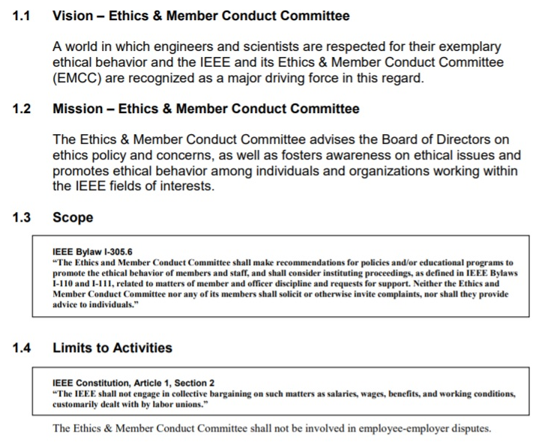
  - Above in 1.3, it authorizes the providing of both Member Conduct and Ethical Support. Further, it attempts to prevent giving ethics advice to individuals. However, as the IEEE Glossary classifies individuals as candidates to membership, it therefore does not limit giving advice to members.
  - Lastly, the sentence following the 1.4 Limits to Activities boxed text, does not apply, as it is not an approved part of Bylaw I-305.5, it resides outside the approved 1.4 material and is at the bottom of the IEEE Governance chain of policy documents. Therefore, it has no effect on IEEE members’ professional activities and does not restrict providing ethics advice and ethical support to members, when requested and justified by the EMCC.
  - NOTE: Just as was done in the 1912 New York Supreme Court ruing allowing business members to serve on the AIEE board (and each succeeding board of IEEE), this sentence represents another attempt to pre-empt member employees’ professional rights with that of business interests, in an appearance of a serious Conflict of Interest non-fiduciary action.
- IEEE Code of Business Conduct
  - Members and Staff are to comply with IEEE Principles of Business Conduct
  - Inquiries and/or complaints may be submitted to the online Ethics Point system for review and follow-up action
- IEEE Code Of Ethics, Policy 7.8
  - Members upon joining or renewing membership agree to uphold the IEEE Code of Ethics
  - In exchange for practicing ethically, IEEE agrees to support the members ethically; Canon 10 of the Code of Ethics
- IEEE Bylaws
  - I-110 Member Discipline and Support
    - The EMCC is empowered to both discipline and support its members ethically
  - I-111 Removal or Suspension of Delegates, Directors and Officers
    - The EMCC is empowered to remove or suspend
  - I-305.5 Ethics and Member Conduct Committee (same as above part of EMCC Operations Manual.
- IEEE Policies
  - 7.10 Procedures for Member Conduct Complaint
    - The EMCC’s procedures for disciplining members are provided
  - 7.11 Ethical Support
    - The EMCC’s procedures for providing Ethical Advice and Ethical Support are provided
  - 7.100 Registration of US Engineers
    - Procedures for licensing Professional Engineers are provided
- Prior IEEE Ethical Support Cases Handled by IEEE, CSIT, MCC, SSIT (discussed below, later)
  - The IEEE BART Case Brief 1975 (prior to the being a MCC)
  - IEEE's CSIT/MCC Support of Virginia Edgerton 1978
  - IEEE's MCC Support of Salvador Castro 1998

