What Started as A 2 Year Ethics Pursuit, Led to the Ad Hoc Committee on Ethics Programs Looking into “Ethics Advice and Ethical Support” and Charles Turner Now Gets the Credit

Walter L. Elden, welden@cfl.rr.com
March 17, 2017
Purpose

I wish to finally cite Dr. Charles Turner, (Professor Charles W Turner, FREng, FIET., Emeritus Professor of Electrical Engineering, King's College London, and a Life Fellow IEEE) to be given herein the credit for causing me to undertake this 2 year effort to get the IEEE to restore “ethics advice and ethical support” for it its Members, after a more than 15 year prohibition against it.

How This Came About

During the summer of 2015, when my wife was out of town visiting her side of the family in Chicago, I took off a few days and checked into a motel on the resort island near Jacksonville, Fl called Amelia Island and Fernandina Beach. I took my laptop with me and my golf clubs. I intended to do some work on getting up to date on what IEEE and the Ethics and Member Conduct Committee were doing in the ethics area and play some golf.

While doing a Google search on IEEE ethics and the EMCC, a slide presentation by Charles Turner, whom I did not even know of then, popped up, and I viewed his Power Point slides, at this WEB site:

http://web.eecs.umich.edu/~aey/eng100/lectures/pdfshort/ethicslecture.pdf

In particular, Slide #11 got my attention, and I became really disturbed by what was displayed on its bottom, as shown next:
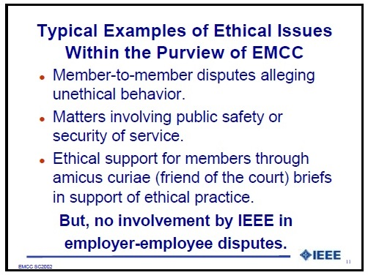
The Phrase: “But, no involvement by IEEE in employer-employee disputes”
jumped right out at me. I said to myself: “NO WAY IS THAT GOING TO STAND”; after all, I and others had worked hard in the 1970’s and helped get the original Member Conduct Committee established to offer both recommendations for 1. Member Discipline, and 2. Ethical Support. So I wanted to find out how this came about and where was the authority in IEEE’s Governance documents which authorized it.
But before going on, here I acknowledge Charles Turner for enabling me to find this by having his presentations slides created, posted and left on the WEB. Read about Charles Turner here:

http://www.ieeer8.org/category/member-activities/professional-activities/

My Search for the Source of This Restriction

Once I contacted Charles about this phrase in his slides, he explained what it meant and when it came about. I captured that later in a section of the new IEEE Ethics History Repository, at this WEB location:

http://ethw.org/IEEE_Ethics_History_Repository_(IEHR)#Background_Of_The_Restrictions_On_The_EMCC_-_A_Personal_Account_of_Walter_Elden

Writing a Position Statement About These Restrictions

I proceeded to write a Position Statement document on the results of extensive research I conducted to show how this restriction was invalid and should be declared NULL and VOID. This Position Paper is at this WEB location:

A_POSITION_STATEMENT_DOCUMENTING_ETHICAL_SUPPOPT_RESTRICTION ON THE EMCC (7).docx

Over a period of 18 months, I kept submitting this paper to the highest levels of elected officials of the IEEE without getting any positive response of support, except from a very few. During that time, I decided to create an IEEE Ethics History Repository, or IEHR, to capture what I had learned during my searches. The IEHR came be accessed at this link:

http://ethw.org/IEEE_Ethics_History_Repository_(IEHR)

Finally, last month, our new IEEE 2017 President, Karen Bartleson, who, with the IEEE Board, had established the Ad Hoc Committee on Ethics Programs, assigned it to look into my reporting about the IEEE restricting the giving of “ethics advice and ethical support” and to advise her and the Board of their findings/recommendations. So that is where we are today, starting with my accidently finding Charles Turner’s Slide #11 on the Internet.

The Future Outcome

I do not know what will become of this, but I will continue working to get “ethics advice and ethical support” both restored to the IEEE Members who are owed it.

