IEEE Members of the Concerned Ethics Volunteers, CEV
Who Contributed to the Ad Hoc Committee on Ethics Programs by Recommending for IEEE to Restore Ethics Advice and Ethical Support to IEEE Members

Jeanette Barott, PhD 2018, IEEE Senior Member

Jeanette is a full-time staff member working in academic program assessment and strategic planning (and Adjunct Professor in Computing) for the College of Engineering at Embry Riddle Aeronautical University’s Daytona Beach Campus. She is the Past Chair of the Daytona Beach IEEE Section and the current interim Secretary for the Florida Council. Attending the IEEE Sections Congress 2017 held in Australia, she kept the CEV informed of developments relevant to its work. She was one of the first IEEE Members who responded to the need to restore ethics advice/support by inviting W. Elden to be the December 2015 IEEE Section speaker on that subject as the subject of ethics tied into her teaching work at ERAU, and she saw the IEEE’s lack of solid, high-quality guidance for its related academic disciplines at odds with the level of contribution she saw from other professional organizations.

At the end of Elden’s talk, she asked him “Why at your age (then 84) are you devoting so much energy to trying to “restore ethics advice and ethical support” to IEEE Members, when you could be out playing more golf?” Elden then responded 2 years later, after considering her question over time, “Because it just needed to be done.”

Barott was the youngest of the CEV members, the others being IEEE Life Members. Let’s hope other young women and men in IEEE will now join her to carry on her commitment to ethical practice and support. Or who will????

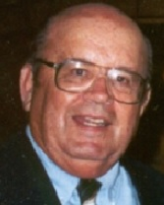 | Walter Elden, P.E. (Ret), IEEE & SSIT Life Senior Member  Walter Elden organized and led the Concerned Ethics Volunteers as its Editor and interfaced with Dr. Greg Adamson, Chair of the IEEE Ad Hoc Committee on Ethics Programs. Walter’s first professional contribution to IEEE was in 1972, immediately following the Members voting to change and add “Professional Activities” to its Constitution for the first time. He proposed and got approval to form IEEE’s first Professional Activities Committee in the Orlando Section, then, he led its meetings for the remainder of the year. His strong commitment to Engineering Professionalism and Ethics stemmed from a course of that name taken 60 years prior at the University of Florida.  He then proposed, organized and presented 5 Professional and co-authored 1Technical papers at the 1974 IEEE SOUTHEASTCON’s first Professional Activities papers session (in IEEE too), which gained him severe criticism from his employer for being “too extreme professionally”. His succeeding efforts to promote professionalism, ethics, products and systems safety and becoming licensed Professional Engineers, rewarded him with an enduring “forced resignation under coercion” from that same employer. Later, being a P.E., he testified against 2 defendant manufacturers as an Expert Witness in a mobile home fire case, which killed 2 children, resulting in an award in favor of the parents.  In 1977, he received a phone call from a Virginia Edgerton (now deceased), wherein she requested ethical support in a degradation of service issue she had brought to the head of a New York City Police Dispatch System, which led to her being terminated. He referred her to Dr. Stephen Unger, with past BART Case experience, which led to IEEE’s CSIT and the later IEEE’s Member Conduct Committee got the IEEE Board to provide her ethical support, as MCC’s first such case. Later Elden helped develop the procedures, adopted by the IEEE Board in February 1978, which created the initial Member Conduct Committee. He then presented those IEEE USAC proposals for a MCC to the Board in 1977 for adoption.  He served on the MCC 1996-98, developed the MCC and EC’s first WEB pages and supported the IEEE Ethics HOTLINE leading to his introducing the Salvador Castro Infant Respiratory Defect Case from the Ethics Committee to the Member Conduct Committee in 1998. That led to the IEEE Board voting to support Castro in his court case.  He later discovered EMCC’s restriction against giving ethics advice and ethical support to IEEE Members, in 2015, from a Dr. Charles Turner slide presentation and worked the next 2 ½ years to get it reversed by forming and leading the Concerned Ethics Volunteers. It then advised the IEEE Ad Hoc Committee on Ethics Programs to recommend for the 2017 IEEE Board to restore them, which they did not do at its November 2017 meeting. That still needs to be done.  While working in industry for 40 years, he was responsible for design/development/or proposing airborne data acquisition equipment and ground based information systems ranging from $10,000 up to $1 Billion dollars. In one in-house ethics situation, in 1996, he successfully negotiated and resolved to a mutual satisfaction, an ethics complaint between a senior IEEE Member engineering subordinate and Elden’s Program Manager, achieving a WIN-WIN outcome, in-house. This demonstrated that such a WIN-WIN outcome was possible to achieve.
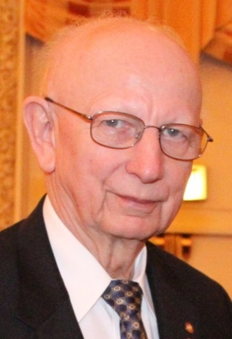 | Raymond Larsen, IEEE Life Fellow Member  He is a special projects engineering manager at the SLAC National Accelerator Laboratory at Stanford University. He founded the IEEE Smart Village and received the Prestigious 2015 IEEE Richard M. Emberson Service Award. He was recognized for “inspiring locally owned businesses to provide sustainable humanitarian benefits in underprivileged communities”.  Larsen originally founded IEEE Community Solutions Initiative in 2009 to address the situation of energy poverty and billions of people with no access to the electric grid. The global humanitarian effort, which in 2014 became IEEE Smart Village, an IEEE Foundation Signature Program.  Smart Village combines the talents of IEEE members with community-owned business partners in energy-impoverished regions to create self-sustaining, micro-utilities and education programs. As Chair of the organization’s Executive committee, Ray is responsible for leading IEEE Smart Village’s total operation including nurturing ten new partnerships per year, each of which pledges to grow to serve a million people.  Ray is past head of the Electronics Department at SLAC National Accelerator Laboratory at Stanford University, Past President of the IEEE Nuclear and Plasma Sciences Society, an IEEE Life Fellow and currently a part-time Special Projects engineering manager at the SLAC in Menlo Park, California. Ray served on the IEEE Ethics Committee in the mid 1990’s and contributed to operating and serving its Ethics HOTLINE. In Ray’s contributions to the CEV, he always offered advice and suggestions based on his years of wisdom which he had acquired.
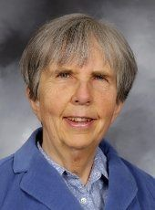 | Dr Martha Sloan, IEEE Life Fellow Member  Martha Sloan received a BSEE with great distinction, an MSEE and a Ph.D. from Stanford University. She has been active in engineering professional societies, having served as treasurer, vice president, and president of the IEEE Computer Society, IEEE, and AAES, which she chaired in 1998. She taught engineering for many years at Michigan Technological University. She retired from Michigan Tech in 2013, becoming a professor emerita, after 43 years of service there.  She is the author of three textbooks and more than 60 papers. She is a Fellow of the ACM, the IEEE and SWE and has received numerous awards, including the SWE Distinguished Engineering Educator Award, an IEEE Centennial Medal, the Richard E. Merwin Award, and the ASEE Outstanding Young Electrical Engineering Educator Award.  In 1993, she became the first woman President of the IEEE. Her service to the profession has been honored by several society fellowships and awards. She served on the Member Conduct Committee 1997-2000, when she chaired the MCC in 1998. As Chair, she proposed the development of an Ethics Conflict Resolution Service, which the MCC prepared a proposal for, but it never got adopted.  It was at one meeting she chaired in 1998 when co-member and Past IEEE President, Wally Read, said “I do not believe the IEEE should get involved in employee-employer ethics disputes.” Shortly thereafter and for over 15 years that view and restricting giving ethics advice were approved by the IEEE Board as Policy.
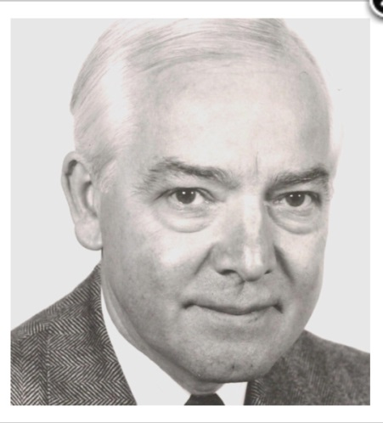 | Dr Charles Turner, IEEE Life Fellow Member  Charles Turner graduated from London University and obtained the PhD degree from Stanford University. He is a Life Fellow of IEEE. He is also a Fellow of the UK Royal Academy of Engineering and a Fellow of the IEE (now IET). He was very active in accreditation activities in the UK, and chaired the IEE Accreditation Committee. He has held several committee positions in Region 8, and was the Region 8 Director from 1993/4, and Secretary from 1999. He was a member of the IEEE Board of Directors, first as Region 8 Director (1993-4), and then as IEEE Secretary in 1995.  Among many other volunteer positions in IEEE he also served on the IEEE Ethics and Member Conduct Committee from 1999-2005 and as its Chair from 2000-2002. In a slide presentation about the EMCC, he disclosed the restriction against “involvement by IEEE in employer-employee disputes”. That then led to the 2017 IEEE Board reversing that restriction.  In contributing to the CEV efforts, Turner always cautioned to steer clear of anything activities which bordered or crossed into the area or Trade Unions or Collective Bargaining, which IEEE’s Constitution covers and prohibits from Professional Activities.
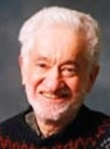 | Dr. Stephen Unger, IEEE Life Fellow Member  He is Professor Emeritus , Computer Science and Electrical Engineering, Columbia University. Prior to coming to Columbia University, Dr. Unger was with the Bell Telephone Laboratories for about five years, doing research and then heading a group developing software tools for the first electronic telephone switching system.  He is the author of "Controlling Technology: Ethics and the Responsible Engineer" 3rd Ed. He was a founder, and later President of, the IEEE (Institute of Electrical and Electronics Engineers) Society on Social Implications of Technology. He served on the Board of Directors of the IEEE, and was a member of the IEEE Technical Activities Board, US Activities Board, Publications Board, and Educational Activities Board. He was a member of the IEEE Ethics Committee from 1995-98, serving as chairman for 1997-98. He also served as a member of the AAUP Ethics Committee.  He played a principal role in the development of the original IEEE Ethics Code and its 1990 revision. He received the IEEE Centennial Medal (1984), the IEEE USAB Distinguished Contributions to Engineering Professionalism Award (1987), and the IEEE Millennium Medal (2000). Dr. Unger is a Guggenheim Fellow, a Fellow of the IEEE and a Fellow of the AAAS.  Steve could be referred to as the one IEEE Member who brought the IEEE into the modern ethics era, with his leadership role in the BART Case, the filing of its landmark amicus curiae “friend of the court” brief in their 3 BART engineers’ suit against BART, and then the efforts which modernized IEEE’s 1912/1950 Code of Ethics in 1974. Then he played an instrumental role which led to IEEE creating its Member Conduct Committee, to a. discipline unethical member conduct, and b. to provide ethical support in matters affecting a Member’s employment.  Later, Unger served and Chaired the IEEE Ethics Committee in the mid-1990’s. Several new ethics advice and support initiatives were introduced, supported successfully, like an Ethics HOTLINE, publishing Bi-Monthly Ethics Articles in the INSTITUTE, forwarding cases like the Salvador Castro one to the MCC. Then, IEEE systematically terminated all this ethics advice and ethical support programs, beginning in 1997, against Unger’s strong objections as Chair of IEEE’s Ethics Committee, to no avail.
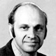 | Victor Zourides, P.E. (Ret), IEEE Life Senior Member  Victor G. Zourides received the Bachelor of Science Degree (Physics) from the Polytechnic Institute of Brooklyn and the M,E.E. from New York University. He is a New York State P.E. (retired). His professional career spanned 40 years in the Aerospace industry.  The first 16 years were spent at Sperry Gyroscope Co. principally as an electronic design engineer; designing electronics from DC to RF. Vic was Long Island Section Chairman 1977 and Region 1 Director 1988-89. He received the 1984 Centennial Award, the 1984 USAB Professional Activities Award and the 1980 Region 1 Award.  The above included Automatic Test Equipment and Pulse Compression efforts. The remaining 24 years were at Grumman Aerospace Corp., principally in management positions including automatic testing of the F-14 of Top Gun fame. In addition, he managed a group for integrating Artificial Intelligence techniques with Built-In-Test to reduce avionics problems. His paper on the work of the group received best paper award at the 1989 IEEE Autotestcon.  Victor, in 1977, was a member of the IEEE USAC Ethics Task Force, along with Dr. Stephen Unger and Walter Elden, P.E. (Ret) who developed the initial procedures which led to the creation of the Member Conduct Committee in February 1978. Vic thereafter was a strong advocate for professionalism and ethical conduct in IEEE practices. He participated and work hard, again with Unger, Elden and others, to restore the Ethics HOTLINE back into service, but was unsuccessful.

SUPPLEMENTAL ETHICS ADVICE AND ETHICAL SUPPORT BACKGROUND

Timeline: Elevating Ethics for Engineers

http://theinstitute.ieee.org/tech-history/technology-history/timeline-elevating-ethics-for-engineers

Key Milestones Missing From an Ethics Support Timeline on The Institute

http://theinstitute.ieee.org/ieee-roundup/blogs/blog/key-milestones-missing-from-an-ethics-support-timeline-on-the-institute

