Right angle paths to solve algebraic equations
by Phillips V. Bradford, Sc.D.

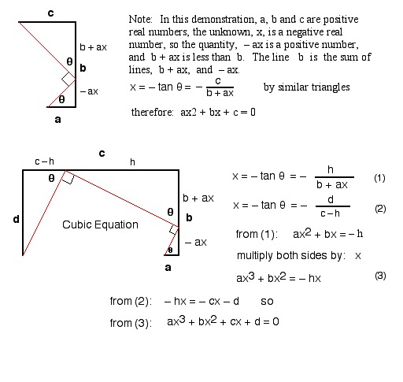

This demonstration allows for iterative extensions into higher degrees, as can be seen in the following, pertaining to quartic equations:
