Restoring IEEE’s Ethical Advice and Support to its Members
in Employee-Employer Disputes

Walter L. Elden, P.E. (Ret)
IEEE and SSIT Life Senior Member
w.elden@ieee.org
Introduction

Since around 2000, the IEEE Board informally prohibited the Ethics and Member Conduct Committee, EMCC, from getting involved in Employee-Employer Professional/Ethical Disputes. Then beginning in 2005, it formally adopted a restriction to that effect, placed it as a one line restriction in 1.4 of the EMCC Operations Manual, along with prohibiting the giving of Ethical Advice. This practice has denied IEEE Members of this Right, granted to them when the IEEE Code of Ethics was adopted in 1974 and subsequently revised, and when formalized in the By-Laws and Policy Statements enacted when the Member Conduct Committee was first established in February 1978. References 1 - 13 document this.

With such denial of ethics advice and support to its Members for the past 15 years, how can IEEE’s Corporate volunteer leaders at the Board and ExCom levels be considered ethical, themselves, for allowing this to go on for so long? How is it I am the first to bring this practice out in the light, and to push for reforms? Did this play any part in the VW emission cheating software designs, created by software engineers, and if yes, does IEEE bare any ethical liability? More on VW later in this article.

This Denial of Ethics Advice and Support Violate IEEE’s Governance Documents

In Ref 1, presenting a POSITION STATEMENT ON THIS, I report on the extensive research of this I undertook during the Fall of 2015 after I accidentally learned of IEEE restricting giving of ethics advice and involvement by its Ethics and Member Conduct Committee, t he EMCC, in employee-employer disputes. In Ref 1, I show where and how in IEEE Governance Documents, its Code of Ethics, and New York State Law, (covering Non-Profit Organizations and their Directors’ duties), are in violation. As a result, I have called for the restoring of Members’ Right to Ethics Advice and Support, by removing that restriction.

TAB/SSIT Task Force Formed to Look into IEEE Ethics and Gaps

As a result of my distributing Ref 1 throughout IEEE to the Officers, Directors and key Leaders worldwide, 1. the INSTITUTE published an Opinion column from me about this issue, 2. the Technical Activities Committee in December 2015 undertook this matter and assigned the Society on Social Implications of Technology, SSIT, to form a Task Force as a result, and 3. I gave an invited talk about my study and findings to the IEEE Daytona Beach Section in December 2015. The TAB/SSIT Task Force was charged with reviewing ethics practices in IEEE and to identify any gaps, and to report back at TAB’s February 2016 meeting. This Task Force will use Ref 1 as a starting point I was informed, as it contains extensive research data, analysis, history, links to IEEE Governance Documents, personal accounts, a proposed Ethics Conflict Resolution Service, ECRS, that was shelved in 1999, eye witness accounts of the founders of the Member Conduct Committee and the Case Histories of Ethical Support in the BART, Virginia Edgerton and Salvador Castro cases supported by IEEE’s Board of Directors in the 1970’s and 1990’s.

Development of Two Supporting Documents Prepared for the TAB/SSIT Task Force

Upon my being informed of the forming of this Task Force, I developed two contributions for it, to expand on my Ref 1 Position Statement document and enable them to get started running, not crawling. These are References 2 and 3.

In Ref 2, I proposed expanding the Task Force to add members from the IEEE USA, covering Regions 1-6, and Regions 7-10, so all of IEEE’s Members are represented. Further, I offered as a starting point to begin building on, a 1998 proposed Ethics Conflict Resolution Service, ECRS, Ref 4, first proposed by former IEEE President Martha Sloan, a Professor at the University of Michigan, and former Chair of the MCC. Then at the end I included some key references supporting the history and the termination of ethical advice and support to IEEE Members. I further strongly recommended doing this putting it in the Constitution, which is voted on by the Members, whereas if in the By-Laws, the Board could change them and did so in 2005 in this instance without any input from Members. We should now have learned we can not trust our own Board to protect our ethical rights. How unethical was that move by the Board?

In Ref 3, I presented an historical walkthrough of IEEE’s involvement in ethics, giving advice and supporting Members, beginning with the formation of the AIEE in 1884, the creation of the IRE in 1912, and ending with IEEE at the end of 2015. In it, I specifically cite when, how and by whom ethics, advice, support and restrictions on same, took place.

Where and to whom has the IEEE in the past provided ethical advice and support, to members placed in jeopardy for trying to uphold our Code of Ethics? Yes, there have been cases, discussed next, but unless we make now take Pro-Active steps, that may continue to be a thing of the past.

IEEE SSIT Has Honored MCC Supported Engineers with the Barus Award

Here are three examples of IEEE Members, who were supported by the Member Conduct Committee and IEEE’s Board of Directors for upholding the Code of Ethics and losing their employment as a result, receiving SSIT’s Barus Award, Ref 12.

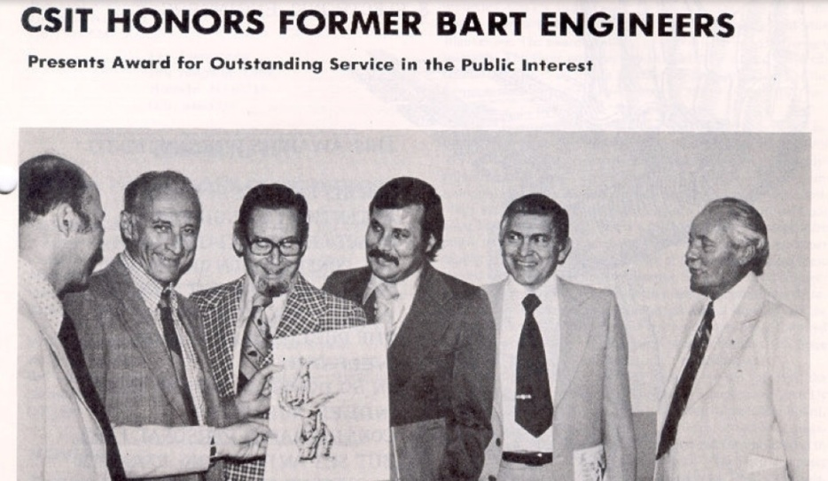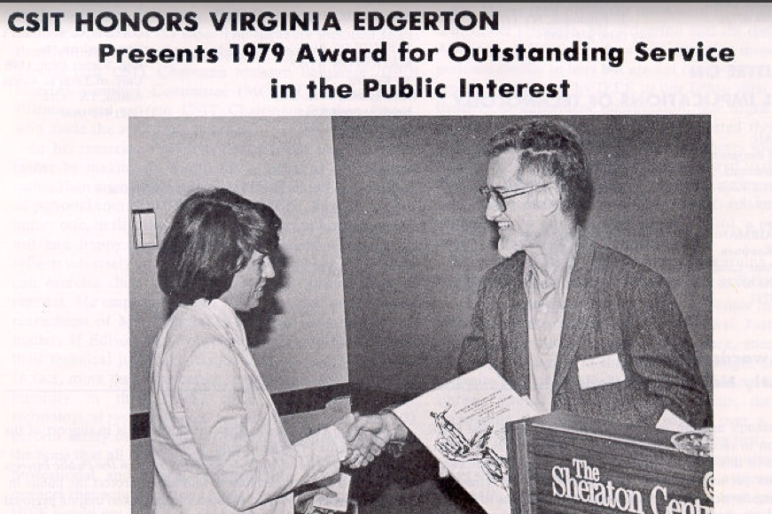

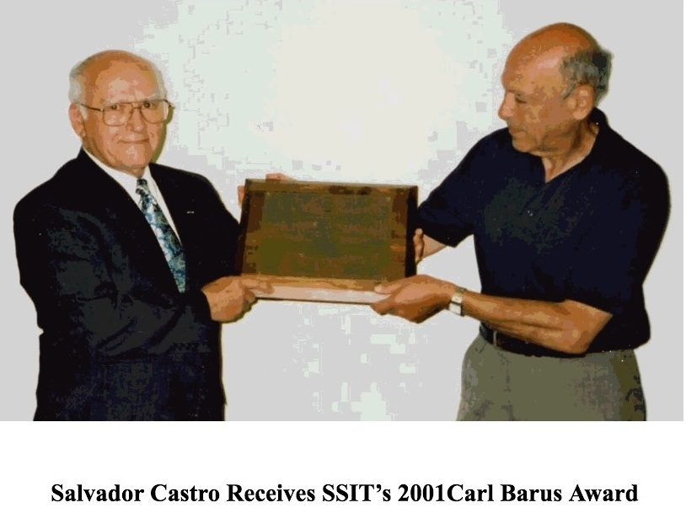

SSIT periodically issues the Barus Award, Ref 12, for "outstanding service in the public interest". A translation of this stands for awards to engineers, while striving to uphold their Code of Ethics, were placed in an employee-employer dispute and had their employment threatened or terminated without due process. This is what was experienced by the 3 BART engineers, Virginia Edgerton and Salvador Castro, each Barus Award recipients, shown in the photos above.

With the ethics advice and support restriction that IEEE put into place 10 - 15 years ago, it is not possible now that IEEE’s Ethics and Member Conduct Committee would be permitted to repeat giving such support any time soon and therefore no more Barus Awards would be given in those missing instances of support. But these 3 awardees highlighted in the photos, documents that there was a time when IEEE did give advice and support and that right needs to be restored.

Engineers, Ethics and the VW Scandal

This is the title of an article in the September 25, 2015 issue of IEEE’s Spectrum, Ref 13. It raised issues of ethics that must have been faced by the software engineers who went along and designed the software whose purpose was to trick in the emission testing of VW vehicles, worldwide, going along with a Corporate dictate and thus failing in their professional and ethical responsibilities to protect the public health, safety and welfare. Did any of the VW software engineers approach the IEEE EMCC for support and get turned away because of this advice and support restriction on the books or in practice since 2000?

In the Spectrum article, it wrote:

“The clever and sneaky algorithm, installed in the emissions-control module, detects when the cars were undergoing emissions testing. It ran the engine cleanly during tests and switched off emissions control during normal driving conditions, allowing the car to spew up to 40 times the U.S. Environmental Protection Agency’s maximum allowed level of nitrogen oxides, air pollutants that cause respiratory problems and smog.”

Here are 3 articles, Ref 13, 14, 15, discussing the how ethics did, did not, and should have, play a major role in the scandal, but here is one viewpoint of total indictment of the VW parties involved:

“What else does it mean? What’s going on here? The episode means that people in positions of authority at Volkswagen devised this scheme, that engineers knowingly signed off on code that would defeat the purpose of EPA and Clean Air Act regulations, and that the massive cheat was allowed to continue for seven years until it was finally detected. This can only happen in a company that is ethically corrupt from the inside out, rooted in an ethics-free, the ends justify the means culture, and yet, before this, no one suspected that VW was more unethical than any other large company. Is it?”

Does the IEEE Bare Any Liability in the VW Software Cheating Design Scandal?

Here, in the VW scandal, we should wonder if IEEE’s restriction against allowing the EMCC to be involved in employee-employer disputes, played any part causing the software engineers who may have asked for IEEE EMCC support were denied it and then they choose to go along and design the cheating software. What, if any, liability could/should IEEE bear in this matter? How many other such deliberate defective product designs resulted from IEEE’s restriction, these past 15 years? Is this what we want our IEEE to stand for? I for one do not.

Conclusions

It was my intention in writing this article to inform many IEEE Members about this ethical support and advice restriction on the EMCC. I wanted to provide Members with the necessary references and WEB addresses for the documentation backing up my findings, conclusions and recommendations. I now urge each reader to inform their fellow IEEE Member about this matter, to read up on it, to get involved, and to advise your leaders and officers that you want them to work to restore your Right to full IEEE ethics advice and support in employee-employer disputes. Be sure and advise the TAB/SSIT Task Force how you feel about this, PRO or CON. The President of SSIT is Greg Adamson g.adamson@ieee.org.

Feel free to contact me if you have any questions or seek clarifications, or wish to comment. I can be contacted at: w.elden@ieee.org

References

1. A Position Statement on EMCC Restrictions in Ethics Employee-Employer Disputes
http://ethw.org/images/d/d6/A_POSITION_STATEMENT_DOCUMENTING_ETHICAL_SUPPOPT_MEANING.doc

2. An Input to the Task Force To Restore IEEE Ethics Advice and Support to its Members
http://ethw.org/images/3/32/An_Input_to_the_Task_Force_Looking_into_IEEE_Ethics_and_Gaps_Therein.pdf

3. An Historical Walk Through of IEEE’s Involvement in Ethics, 1884 – 2015
http://ethw.org/images/d/db/An_Historical_Walk_Through_of_IEEE's_Support_and_Non-Support_of_Ethics%2C_1884-2015.pdf

4. Martha Sloan’s Ethics Conflict Resolution Service Proposal
http://ethw.org/images/9/9b/Ethics_Conflict_Resolution_Service_ECRS.docx

5. The IEEE USAB Ethics Task Force’s Proposals for Ethical Support and Member Discipline presented to the IEEE Board of Directors, November 1977
http://ewh.ieee.org/soc/ssit/Newsletter%20Archive/1972-1981/TS5-20-77.pdf

6. The Assault on IEEE Ethics Support (in 1999)
http://ieeexplore.ieee.org/stamp/stamp.jsp?tp=&arnumber=4274770

7. The Case of the Vanishing Ethics Article(in 2008)
http://ieeexplore.ieee.org/stamp/stamp.jsp?tp=&arnumber=4538973

8. IEEE Has Shown Disregard Towards Proactive Ethics Activities (in 2008)
http://ieeexplore.ieee.org/stamp/stamp.jsp?tp=&arnumber=4623819

9. BART Case : 3 Engineers Fired Who Sued and IEEE Entered an Amicus Curiae:
http://ewh.ieee.org/soc/ssit/Newsletter%20Archive/1972-1981/TS1-4-73.pdf#page=6

10. The Virginia Edgerton Case Involving 911 Delay Flaws, Who was fired:
http://ewh.ieee.org/soc/ssit/Newsletter%20Archive/1972-1981/TS7-26-79.pdf

11. The Salvador Castro Case of the Defective Infant Breathing Device:
http://www.onlineethics.org/cms/23337.aspx

12. The IEEE Society on Social Implications of Technology Barus Award and Awardees
http://ieeessit.org/awards/

13. Engineers, Ethics and the VW Scandal
http://spectrum.ieee.org/cars-that-think/at-work/education/vw-scandal-shocking-but-not-surprising-ethicists-say

14. Professor says Volkswagen scandal a failure of 'ethical engineering'
http://m.phys.org/news/2015-09-professor-volkswagen-scandal-failure-ethical.html

15. The VW Scandal: Huge Consequences, Simple Ethics Lessons
http://ethicsalarms.com/2015/09/27/the-vw-scandal-huge-consequences-simple-ethics-lessons-ominous-implications/

