IEEE’s Involvement in Ethics and the Gaps Needing Fixed
Revised December 26, 2015
(Suggestions from Drs Greg Adamson and Stephen H. Unger, both of IEEE SSIT, incorporated)

Walter L. Elden, P.E. (Ret)
IEEE and SSIT Life Senior Member
IEEE Member Conduct Committee and
Liaison to IEEE’s Ethics Committee 1996-98
w.elden@ieee.org
A discussion on ethics
"For more than 100 years, IEEE has had a code of ethics. Ethics are important as part of our role as a professional organization. At the November 2015 Technical Activities Board (TAB) meeting, the TAB Management Committee asked SSIT to work with some other society representatives to prepare an initial report for the February 2016 TAB meeting on current TAB and society ethics activities, and how these are meeting the needs of our members.
"Walter Elden, a longtime member of SSIT, has written the following background paper – ‘IEEE’s Involvement in Ethics and the Gaps Needing Fixed’ on his experience with IEEE's approach to ethics as input to that report. These are Walter's own views, based on his own experiences. I encourage anyone with experiences or views on the general issue to send these to me, g.adamson@ieee.org, before the end of January 2016. If you are unable to respond by then, but want to express your views, please drop me a note.
Dr Greg Adamson, President (2015-16), IEEE SSIT
g.adamson@ieee.org
_______________________________________________________________________

Introduction

The IEEE, starting with one of its founding Societies, the American Institute of Electrical Engineers, the AIEE, in 1912 adopted its first Code of Ethics. Since then it has since been involved in ethics in various forms through 2015. However, there have been several gaps which have occurred, which this article addresses and advocates being corrected.
For those Members of the IEEE, in particular some of its Directors and Officers who are relatively new in the IEEE, may lack the history of IEEE’s ethics involvement and then the gaps which subsequently developed. So it will be important for those to read up and learn this important history, to be in an informed position to decide what corrective actions should now be made to restore IEEE to its former leadership role in ethical advice and support of code compliance practices. This article presents a mere overview introduction of this.

Evolutionary Revisions to IEEE’s Code of Ethics
In 1950, a first revision to the 1912 Code was made, based upon the Canons adopted by the National Society of Professional Engineers, the NSPE. But this 1950 code was not even known about when IEEE entered its landmark Amicus Curiae “friend of the court” legal brief in the BART Case supporting the legal obligation of them to uphold ethics in their line of engineering work. Then in 1972 following IEEE Members voting YES by over 82%, it amended its Constitution and added involvement in “professional activities” for the first time. Following this, in 1974, it adopted a more modern day version of its Code of Ethics, and since then several more times it has been revised, the latest in 2014.
IEEE Debated Whether to Just Discipline Members But Not Support Them Upholding Ethical Practice
In the mid 1970’s, two different viewpoints were debated regarding upholding the Code of Ethics (5). The IEEE Board wanted procedures to just discipline Members when they were alleged to have violated the Code. Members in the Committee on Social Implications of Technology, IEEE’s Technical Activities Board, TAB, and the United States Activities Board, USAB, took a different view. They argued that if a member were to be subjected to discipline procedures, which they all supported, then they believed that they should also be supported for trying to uphold ethical principles of the Code of Ethics, especially when in placed their employment in jeopardy. Ultimately, these two viewpoints were combined, and the Member Conduct Committee, the MCC, was formed to implement both Discipline and Support procedures, in February 1978.
Ethical Support Became Institutionalized, Resulting in Several Milestone Cases
During the next 20 years, until 1998, IEEE supported 3 important cases handled by either the CSIT/SSIT or the MCC. These were the BART, Virginia Edgerton and Salvador Castro cases (9, 10, 11). In each, following investigations corroborating claims brought to IEEE about these cases, the Board voted to support each, through either legal, publishing about each case, or recognizing their actions by giving them a new award, named in honor of Carl Barus, of the Society on Social Implications of Technology, SSIT.
IEEE SSIT Honored MCC Supported Engineers with the Barus Award

Here are the three examples of IEEE Members, who were supported by the CSIT/SSIT, the Member Conduct Committee and IEEE’s Board of Directors, for upholding the Code of Ethics and losing their employment as a result, receiving SSIT’s Barus Award, (12).

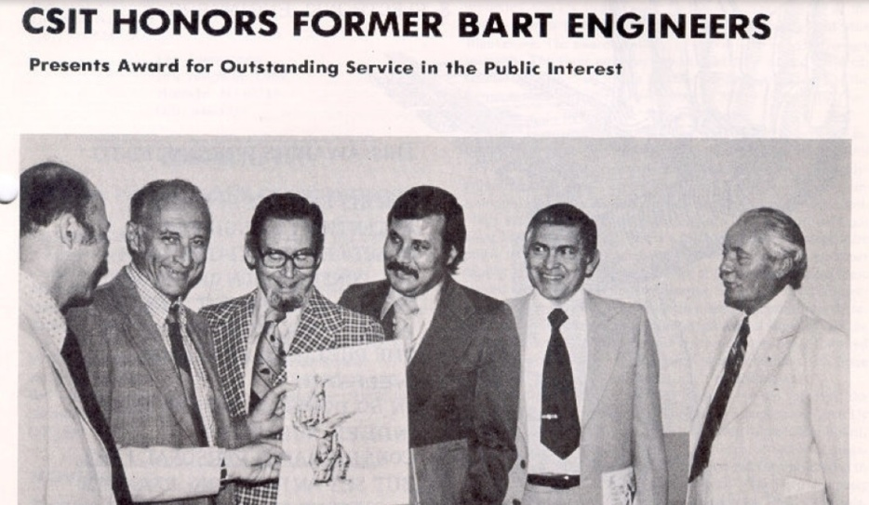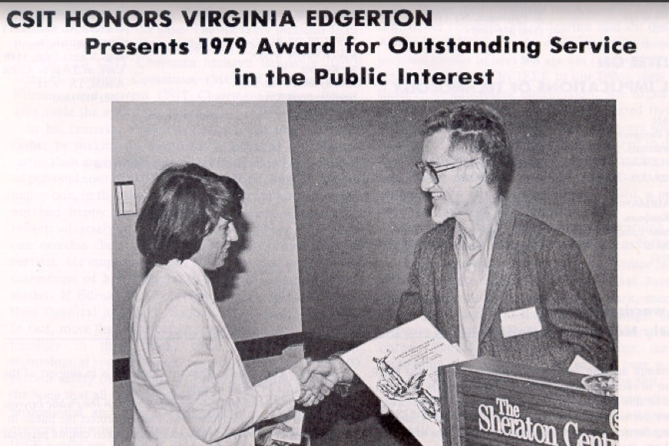

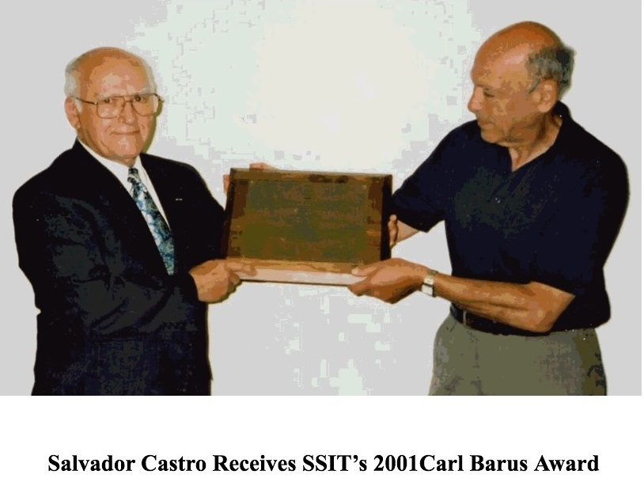

SSIT aperiodically-often with several years between consecutive awards-issues this Barus Award, (12), for "outstanding service in the public interest". A translation of this stands for awards to engineers, while striving to uphold their Code of Ethics, were placed in an employee-employer dispute and had their employment threatened or terminated without due process. This is what was experienced by the 3 BART engineers (9), Virginia Edgerton (10), and Salvador Castro (11), each Barus Award recipients, shown in the photos above.

Other Ethics Activities IEEE Was Involved In

During the 1990’s, until 1998, IEEE’s Ethics Committee operated an Ethics HOT Line, from mid August 1996 thru mid August 1997, very successfully, without any problems. It further established an Ethics Support Fund, into which voluntary contributions were envisioned could have been made, But while there had been developed this plan for the ethics support fund, it was never permitted to actually establish one.

. Further, it got the Membership Renewal process to require each Member to agree to abide by IEEE’s Code of Ethics, as one condition for renewing membership. Lastly, it began regularly publishing on a bi-monthly basis, an article in the INSTITUTE, written by members of both the Ethics Committee and the Member Conduct Committee. In the MCC, Martha Sloan, a Past IEEE President and then the MCC Chair, had proposed an Ethics Conflict Resolution Service, the ECRS (4).

Even though these services had operated successfully, and if the ECRS had been implemented, by 1999 they each had been terminated, without any input or notice to IEEE's Members. Today, when an IEEE Member is faced with an ethical conflict situation, in his/her place of employment, and asks the Ethics and Member Conduct Committee for ethical advice or support in these matters, they cannot be provided any. This has been IEEE's approved policy, first informally beginning around 2000, then formalized in 2005, with insertion of 2 restrictions in 1.3 and 1.4 of the EMCC's Operations Manual (13), as shown in the illustration next.

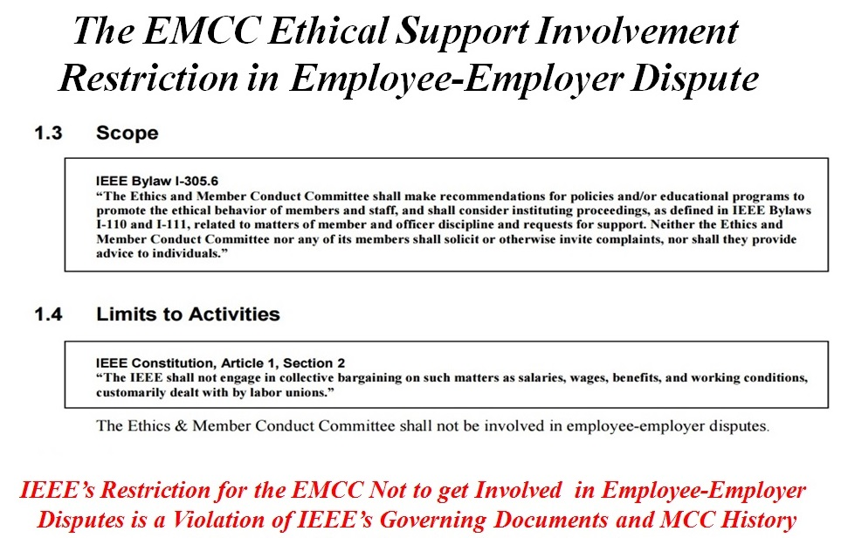

Conclusions

Historically IEEE has supported several Codes of Ethics since its first Code in 1912. With creation of the Member Conduct Committee in 1978, until 1998, its charter was twofold; 1. Discipline and 2. Support. Now, it is empowered only to handle Discipline cases. A question Members must consider is whether reactivating the Ethics HOT Line, giving ethical advice and providing ethical support services, would adequately bridge the gap in ethics created when they were terminated in the late 1990's. IEEE's Members will have to decide this.

I have considered Dr. Stephen H. Unger, of IEEE’s CSIT/SSIT, to have been my ethics mentor, berginning in the early 1970’s with the BART case investigation he led. While reviewing and commenting on this article for me, he wrote these prophetic words about IEEE’s ethical support dilemma:

“I admire you for having the stamina to take another stab at getting the IEEE to re-start ethics support. I think that the key element will be the extent to which some young IEEE members get excited enough to pick up the torch. In all the years since we got crushed in the late 90s, I can't recall ever receiving any inquiry from a young IEEE member about IEEE ethics support”. Stephen H. Unger, 12-24/2015

Comments and Suggestions Are Invited

Inputs are invited for the SSIT Task Force to study this for TAB. Be sure and advise SSIT and/or other IEEE entities how you feel about this, PRO or CON. The President of SSIT is Greg Adamson g.adamson@ieee.org. Feel free to contact me if you have any questions or seek clarifications, or wish to comment. I can be contacted at: w.elden@ieee.org

Reference and Historical Material on IEEE’s Ethics and Gaps

1. A Position Statement on EMCC Restrictions in Ethics Employee-Employer Disputes
http://ethw.org/images/d/d6/A_POSITION_STATEMENT_DOCUMENTING_ETHICAL_SUPPOPT_MEANING.doc

2. An Input to the SSIT Task Force To Restore IEEE Ethics Advice and Support to its Members
http://ethw.org/images/3/32/An_Input_to_the_Task_Force_Looking_into_IEEE_Ethics_and_Gaps_Therein.pdf

3. An Historical Walk Through of IEEE’s Involvement in Ethics, 1884 – 2015
http://ethw.org/images/d/db/An_Historical_Walk_Through_of_IEEE's_Support_and_Non-Support_of_Ethics%2C_1884-2015.pdf

4. Martha Sloan’s Ethics Conflict Resolution Service Proposal
http://ethw.org/images/9/9b/Ethics_Conflict_Resolution_Service_ECRS.docx

5. The IEEE USAB Ethics Task Force’s Proposals for Ethical Support and Member Discipline presented to the IEEE Board of Directors, November 1977
http://ewh.ieee.org/soc/ssit/Newsletter%20Archive/1972-1981/TS5-20-77.pdf

6. The Assault on IEEE Ethics Support (in 1999)
http://ieeexplore.ieee.org/stamp/stamp.jsp?tp=&arnumber=4274770

7. The Case of the Vanishing Ethics Article(in 2008)
http://ieeexplore.ieee.org/stamp/stamp.jsp?tp=&arnumber=4538973

8. IEEE Has Shown Disregard Towards Proactive Ethics Activities (in 2008)
http://ieeexplore.ieee.org/stamp/stamp.jsp?tp=&arnumber=4623819

9. BART Case : 3 Engineers Fired Who Sued and IEEE Entered an Amicus Curiae:
http://ewh.ieee.org/soc/ssit/Newsletter%20Archive/1972-1981/TS1-4-73.pdf#page=6

10. The Virginia Edgerton Case Involving 911 Delay Flaws, Who was fired:
http://ewh.ieee.org/soc/ssit/Newsletter%20Archive/1972-1981/TS7-26-79.pdf

11. The Salvador Castro Case of the Defective Infant Breathing Device:
http://www.onlineethics.org/cms/23337.aspx

12. The IEEE Society on Social Implications of Technology Barus Award and Awardees
http://ieeessit.org/awards/

13. IEEE’s Ethics and Member Conduct Committee Operations Manual
http://www.ieee.org/documents/emcc_opm_feb09.pdf

