Applets
by Phillips V. Bradford, Sc.D.
The Java Applets may need a special web browser plugin to use. Web browser security settings could block the usage of Java Applets. Java Applets generally do not run on mobile devices.

1 Perpendicular Line Applet

Perpendicular Line Applet

Notes:
If you mouse click and release anywhere on this Applet, then hit "return" a new frame will appear that can be expanded and moved around.
The code for this Applet is based upon David Joyce's Geometry Applet.

2 Simple Filters Applet

Simple Filters Applet

In this Simple Filters Applet, R is the resistance of the resistor at the output terminals. The point, ZL is the impedance of the inductor in the low-pass filter in series with R. The point ZC is the impedance of the capacitor in the high-pass filter in series with R. At their initial points, both filters are showing their conditions when the frequency w, is the "cut-off" frequency, so that the impedances ZL and XC are both at 45 degree angles with respect to R.
The point, R may be dragged horizontally, and the point ZL can be dragged up and down along the vertical reactance axis. The origin, O, cam also be dragged in any direction.
This applet shows how the magnitude and phase of the transfer function, H, can be geometrically realized. The magnitude of H is simply the ratio of the length of the red R line to the length of the ZL or ZC blue diagonal lines. The phase of the output to the input is the negative of the angle formed between the ZL or ZC line and the horizontal R axis line.
The applet may be reset to its original appearance by pressing the space bar and the applet may be put onto a separate page by clicking your mouse on the applet and pressing the enter (or return) key.

3 Geometric Visualization of a Cube Root

Geometric Visualization of a Cube Root Applet

Notes:
The orange path forms right angles when it intersects with the axes. x cubed = a; or the cube root of a = x
Proof: By the laws of right triangles: (a)(x) = b squared, and (1)(b) = x squared, so (a)(x) = (x)^4 or a = x^3. If given x, one can determine a using compass and unmarked straight-edge construction, However, if given a, one cannot, in general, determine x, using compass and unmarked straight-edge construction.
If you mouse click and release anywhere on this Applet, then hit "return" a new frame will appear that can be expanded and moved around.
The code for this Applet is based upon David Joyce's Geometry Applet.

4 Series Impedance Applet

Series Impedance Applet

In this series impedance applet, the red lines, Z1 and Z2 are impedances that are wired in series. The red line terminating in the black dot, Z is the vector sum of Z1 and Z2. The vector Z represents the impedance of the series combination of Z1 and Z2.
The red points, Z1 and Z2 may be dragged around, and the axis wL, 1/wC, can be extended, and the origin, O can be slid along the vertical axis by dragging with your mouse.
The applet may be reset to its original appearance by pressing the space bar and the applet may be put onto a separate page by clicking your mouse on the applet and pressing the enter (or return) key.

5 Parallel Impedance Applet

Parallel Impedance Applet

In this parallel impedance applet, the red lines, Z1 and Z2 are impedances that are wired in parallel. The intersection of the two circles is the parallel combination,Z, of Z1 and Z2. The purple vector, Z, from the origin, O, to the intersection of the two circles represents the impedance of the parallel combination of Z1 and Z2.
The points, Z1 and Z2 may be dragged around, and the axis wL, 1/wC, can be extended, and the origin, O can be slid along the vertical axis by dragging with your mouse.
The applet may be reset to its original appearance by pressing the space bar and the applet may be put onto a separate page by clicking your mouse on the applet and pressing the enter (or return) key.

6 Parallel Reactance Applet

Parallel Reactance Applet

In this parallel reactance applet, the red points, X1 and X2 are reactances shown on the vertical axis that are wired in parallel. The intersection of the two diagonal green lines at the black point, X, is the parallel combination of X1 and X2. The vector from the origin, O, to the intersection of the two diagonal green lines, at X represents the reactance of the parallel combination of Z1 and Z2.
The points, X1 and X2 may be dragged up and down along the vertical reactance axis, and the axes wL, 1/wC,and R can be extended, and the origin, O can be slid along the vertical axis by dragging with your mouse.
Note that the initial position of X1 is inductive and the initial position of X2 is capacitive. As X1 is slid down toward the origin, O, the parallel reactance, X, first progresses to minus infinity (at resonance) and then as the magnitude of X1 become less than the magnitude of X2 the parallel reactance, X, reappears from plus infinity.
The applet may be reset to its original appearance by pressing the space bar and the applet may be put onto a separate page by clicking your mouse on the applet and pressing the enter (or return) key.

7 Synthesis of a Matching Network by Geometric Circuit Design

Synthesis of a Matching Network by Geometric Circuit Design

Synthesize a Matching Network Applet

In this parallel reactance applet, the point, R1 is the load resistance (impedance) to be matched at the output and R1 is the input resistance (impedance) of the source.
Synthesis procedure:
1. Draw a circle (shown in green) with its diameter along the R axis that passes through the origin and R1. The center (black dot) of the circle is the midpoint of R1.
2. Draw a vertical line (shown in green) through R2 that intersects the circle below the R axis.
3. Draw a line (shown in red) from R1 through the intersection point to the vertical X axis. The distance from the origin to the red point on the X-axis is the capacitive reactance, 1/wC, that determines the value of capacitance to be placed in parallel with the load resistance, R1. The purple impedance, Z, is the impedance of the parallel combination of C and R1.
4. Add a vertical inductive reactance, wL to Z up to the R axis, where it will form R2, to match the input impedance. The inductance, L is determined by the length of this vertical iine segment.
The points, R1 and R2 may be dragged along the horizontal resistance axis and the axes wL, 1/wC,and the origin, O can be slid along the vertical axis by dragging with your mouse.
Note that R1 > R2 and Z is capacitive in this example. The circuit can be simply reversed to match a higher R2 to a lower R1. The circuit can also be made with a parallel inductor and a series cpacitor. The latter would also serve as a low pass filter, while the circuit as shown serves as a high pass filter.
The applet may be reset to its original appearance by pressing the space bar and the applet may be put onto a separate page by clicking your mouse on the applet and pressing the enter (or return) key.

8 Geometric Visualization of Voltage Dividers Applet
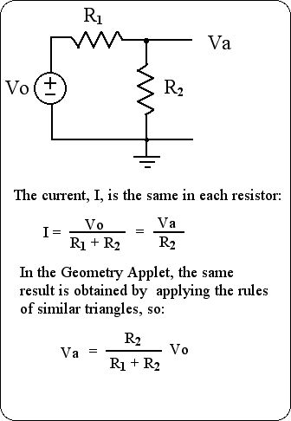
Notes:
If you mouse click and release anywhere on this Applet, then hit "return" a new frame will appear that can be expanded and moved around.
The code for this Applet is modified from the original work of David Joyce's Geometry Applet.

9 Geometric Visualization of Parallel Resistors with Applet
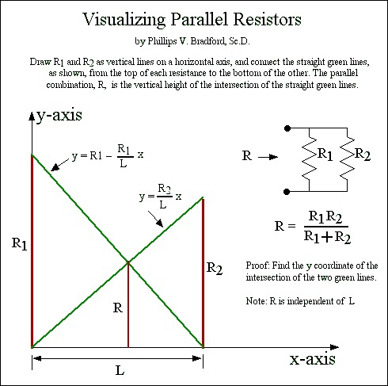
The red lines,"R1" and "R2", represent the resistance of two resistors. The parallel circuit combination of these two resistors forms a combined resistance represented by the short red line, "R". R = (R1)(R2)/(R1 + R2) and is constructed by drawing the green lines and locating their mutual intersection. Note that R is independent of the separation distance between points B and E.
Notes:
If you mouse click and release anywhere on this Applet, then hit "return" a new frame will appear that can be expanded and moved around.
The code for this Applet is modified from the original work of David Joyce's Geometry Applet.

10 Geometric Visualization of Parallel Resistance and Reactance Applet

When a resistor, R, is in parallel with an inductor, L, or a capacitor, C, the resultant impedance can be found in the Z-plane, which is the right half-plane of the complex number field, R + jX, where j is the "imaginary" square root of -1, as follows:
Represent the resistor, R, as a vector directed along the x-axis as shown by the Red line, marked, with a red R, in the figure above. Represent an inductor by X = wL, a vector along the positive jX axis, shown in black, with a red tip marked wL Its length will be the product of the angular frequency (w = omega) of the a.c. sinusoidal excitation voltage for the parallel combination times the inductance, L. This product is its inductive reactance, X = wL.
Join the heads of the inductive reactance vector, the red point wL, to the head of the resistance vector, the red point R, with the straight line, shown in green.
Find the vector, ZL (in purple), which begins at the origin and terminates on the green line such that it intersects the green line at a right angle. The blue circle, with diameter, R, constructed around the red R vector will also intersect the green line at the same point, and is the locus of such intersections as L, or omega, is changed.
For a resistor in parallel with a capacitor, the capacitive reactance is the reciprocal of the product of capacitance, C, and the angular excitation frequency, omega, as indicated in the figure by the red point 1/wC.
The angular phase difference between the sinusoidal current through the resulting impedance and the applied sinusoidal voltage across the impedance is the angle between the ZL or Zc vector and the real x-axis (or R-axis).
The simplest proof of this geometric representation of a resistance in parallel with an inductive reactance is as follows.
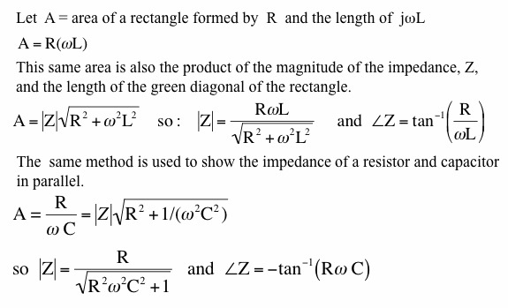
Another proof of this is shown by writing an equation for the green line, and for the line on which the vector, Z, lies. The slope of the line for the Z vector is the negative inverse of the slope for the green line, because they are perpendicular to each other. The point of intersection of the the two lines is found by the simultaneous solution of the two equations for the two lines, and the coordinates of this point correspond to the real and imaginary parts of the impedance of the parallel combination.
Most elementary electrical engineering texts show the resultant vector sum of series connected resistances and reactances as the (parallelogram) vector sum. The parallel combinations are shown as vector sums in the admittance-plane, or Y-Plane, which is the complex inverse of the Z-plane. The advantage of the visualization shown here is that both series and parallel combinations can be treated in the same diagram. The value of this is in the synthesis of a.c. circuits which will be shown in subsequent web pages.
The points, O, wL and 1/wC may be be dragged vertically, and the point, R, can be slid along the horizontal axis by dragging with your mouse.
The applet may be reset to its original appearance by pressing the space bar and the applet may be put onto a separate page by clicking your mouse on the applet and pressing the enter (or return) key.

11 Applet showing Lill’s method applied to cubic equations

Applet figure showing the right-angle paths that represent a cubic equation with real solutions
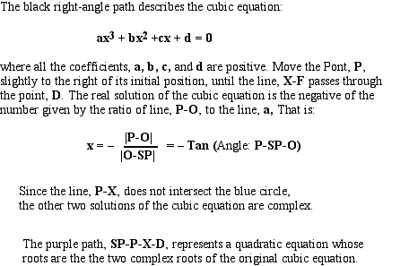
The horizontal green line is the x-axis where the point O represents x = 0, and distances are measured in units of a, the fixed distance between points O and SP (starting point). The initially positive coefficients, b, c, and d can be adjusted by moving the points B, C, and D respectively. The point P is constrained to move along the x-axis and the purple line E-P is constrained to be perpendiculat to the purple line P-SP, and the point E can be extended as needed until it crosses the line c or its vertical extension. The point, X, marks the intersection of the purple line P-E and the vertical line c or its extension. The point F can be extended as far as needed. Real solutions to the cubic equation are found as the length of the line P-O whenever the line F-X lies on the point D. If the line P-X intersects the blue circle, then there will be three real solutions to the cubic equation: The right-angle path SP-P-X-D describes a quadratic equation, whose two solutions are also solutions to the cubic equation.
If the mouse cursor is clicked on the applet and then the space bar is pressed, the applet will reset to its original position. The applet can be enlarged by clciking on the applet, pressing the return key, and dragging the lower right corner of the applet to any desired size.
References
Lill's method was first described in: Nouvelles Annales de Mathematiques. , Series 2, Vol. 6, 1867, page 35.

12 Applet showing Lill’s method applied to quadratic equations

Applet figure showing the right-angle paths that represent a quadratic equation with real solutions
The horizontal blue line is the x-axis where the point O represents x = 0, and distances are measured in units of a, the fixed distance between points O and SP (starting point). The positive coefficients, b and c can be adjusted by moving the points B and C, respectively. The point x is at the end of one purple line connected to the starting point SP, and can slide along the x-axis until the Point P coincides with the point C. This will happen at the two locations, where x falls on the point where the blue circle intersects the x-axis. The solution values of x are then given by the distance between points O and x. The value of x is positive when the point x is to the right of the point O, and negative otherwise. If the blue circle does not intersect the x-axis, the point x cannot rest on any point along the x-axis where the points P and C can coincide, therefore the roots are complex.
If the mouse cursor is clicked on the applet and then the space bar is pressed, the applet will reset to its original position. The applet can be enlarged by clicking on the applet, pressing the return key, and dragging the lower right corner of the applet to any desired size.
References
Lill's method was first described in: Nouvelles Annales de Mathematiques. , Series 2, Vol. 6, 1867, page 35.

13 Applet showing a geometric method to find complex solutions to quadratic equations

Applet showing a geometric method to find complex solutions to quadratic equations

Applet to show the geometric solutions to a quadratic equation:
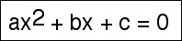
In the geometric diagram, the right-angle path SP-O-B-C represents the quadratic equation, with positive coefficients, a, b, and c. The points, B and C, may be moved to show the effects of changes in the coefficients in both magnitude and sign. The line a' extending above the point B is equal to the line a. The red points x and x* show the positions of the two complex conjugate solutions in the x, y plane, where the x-axis is the horizontal blue line, with x = 0 at the point O and the y-axis is the vertical imaginary number axis. As the coefficients are moved, the solutions will move, and when the faint yellow circle intersects the x-axis, the solution will be real and will lie along the x-axis at the red points, x1 and x2.
If the mouse cursor is clicked on the applet and then the space bar is pressed, the applet will reset to its original position. The applet can be enlarged by clicking on the applet, pressing the return key, and dragging the lower right corner of the applet to any desired size.
References
Lill's method was first described in: Nouvelles Annales de Mathematiques. , Series 2, Vol. 6, 1867, page 35.
The code for this Applet is modified from the original work of David Joyce's Geometry Applet.

