AN APPRECIATIVE BOOK REVIEW

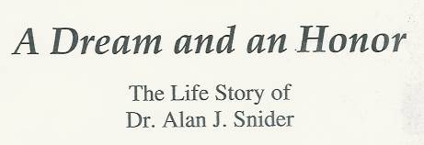

I first met Dr. Snider in 2012 and we talked about our respective careers. He gave me a copy of his book detailing his boyhood dream which culminated in the establishment of Sun Coast Hospital and over 50 years of growth to date. I found that we shared the same initial resistance to writing our life stories but both finally gave in to pressure from friends, family and business associates. Dr. Snider’s work has provided us with a blueprint for tackling that seemingly impossible task of writing ones life story. Anyone interested in the book may contact The Suncoast Hospital Foundation, 1793 Indian Rocks Road, Largo, FL 33774.

This review focuses on the books usefulness as a teaching tool for any one writing his life story. The 27 chapter titles provide the life story outline. Recalling memorable life events appears to be a good place to start. This approach makes the seemingly monumental writing job achievable. A small start can be expanded as needed during the actual writing process.

Using this method, I prepared a two page summary outline of my career to date for publication in the IEEE 50th Anniversary History Center Archives. This method has also been taught at The Pinecrest Independent Living Community by Diana Baldwin, Activities Director, in her “My Life Story” journaling classes. The book is used as an example for students as they begin their life story writing journey.

I am attaching this review to my Abstract Table Of Contents to acknowledge Dr. Snider’s many contributions and for becoming part of my continuing life story.

Respectfully submitted,

Thomas J Radcliffe, P.E.
April 2013

