IEEE – 125 YEARS DEVOTED TO THE BENEFIT OF HUMANITY
Goce Arsov¹, Vladimir Katic², Vladimir Dimcev¹, Ljubomir Nikoloski¹
¹SS Cyril and Methodius University, Faculty of Electrical Engineering and Information Technologies, Skopje, Republic of Macedonia
²University of Novi Sad, Faculty of Technical Sciences, Novi Sad, Republic of Serbia
g.arsov@ieee.org, katav@uns.ac.rs, vladim@feit.ukim.edu.mk, nljube@feit.ukim.edu.mk

Abstract – This paper is dedicated to the 125 anniversary of IEEE as one of the largest world professional organization. Beside the historical facts about the evolution of IEEE from AIEE and IRE the paper concentrates on the meaning of the organization logo, on the IEEE today. A short history of IEEE in former Yugoslavia and nowadays IEEE sections: Bosnia and Herzegovina Section, Croatia Section, Republic of Macedonia Section, Slovenia Section and Serbia and Montenegro Section, as local entities from 340 existing all over the world is presented.
Keywords – IEEE, IRE, AIEE, IEEE in former Yugoslavia

INTRODUCTION
Today electric power, radio, television, telephones as well as wireless communication systems, and computers, are just some of the products based on electrical engineering.
IEEE's roots go back to 1884 when electricity was just beginning to become a major force in society. At the beginning of the 1840s there was one major established electrical industry, the telegraph. During the second half of the XIX century, as a result of the inventions of Bell, Green, Hamilton, Pope, Edison, Tesla etc. (the telegraph, telephone, electric light, dynamo, poly-phase system), electricity begun to be used for communication, light, power and transportation. The rapidly growing art of producing and utilizing electricity raised the question of efficient dissemination of new technologies and protection of inventor’s authorship. As a consequence the professional exhibitions were organized and professional journals, like: ”The Telegrapher – journal of electrical progress“, and “Electrical World” were published as regular issues. In 1880s, the civil and mechanical engineers already had societies in order to promote their common goals. On the other hand, only the physicists were publically recognized and had the authority to discuss the problems related to the development of electrical engineering. Therefore the need of establishing a new professional organization arose. The electrical engineering had to be established as a respected profession as this field posed special opportunities and problems. As a result of these needs, in 1884 a group of electrical engineers leaded by Norvin Green (1818-1893), established the American Institute of Electrical Engineers – AIEE.
At the turn of the century a as a result of the work of Maxwell, Hertz, Tesla, Popov, Marconi and others, a new industry arose, beginning with wireless telegraphy experiments. What was originally called "wireless" became radio with the electrical amplification possibilities inherent in the vacuum tubes which evolved from John Fleming's diode and Lee de Forest's triode. With the new industry came a new society, established in New York in May 1912, the Institute of Radio Engineers. The IRE was modeled on the AIEE, but was devoted to radio, and then increasingly to electronics. It, too, furthered its profession by linking its members through publications, standards and conferences, and encouraging them to advance their industries by promoting innovation and excellence in the emerging new products and services.
Through the help of leadership from the two societies, and with the applications of its members' innovations to industry, electricity wove it’s more deeply into every corner of life: television, radar, transistors, and computers. Increasingly, the interests of the societies overlapped. Membership in both societies grew, but at the beginning of the 1940s, the IRE grew faster and in 1957 became the larger group. On 1 January 1963, The AIEE and the IRE merged to form the Institute of Electrical and Electronics Engineers, or IEEE. At its formation, the IEEE had 150,000 members, 140,000 of whom were in the United States.
By the early 21st Century, IEEE served its members and their interests with 38 societies; 130 journals, transactions and magazines; more 300 conferences annually; and 900 active standards. As technologies and the industries that developed them increasingly transcended national boundaries, IEEE kept pace, becoming a truly global institution. By 2008, IEEE had 375,000 members in 160 countries, with 43 percent outside of the country where it was founded a century and a quarter before. Through its worldwide network of geographical units, publications, web services, and conferences, IEEE remains the world's leading professional association for the advancement of technology. Slovenia, Croatia, Serbia & Montenegro, Bosnia &Herzegovina, and Republic of Macedonia IEEE Sections and their members are part of this outstanding family of engineers.

FOUNDATION OF AIEE [1], [2], [3], [4]
On April 5th an invitation to the organizational meeting for establishing a national electrical society, AIEEE, was published in ”Electrical World”, (Fig. 1).
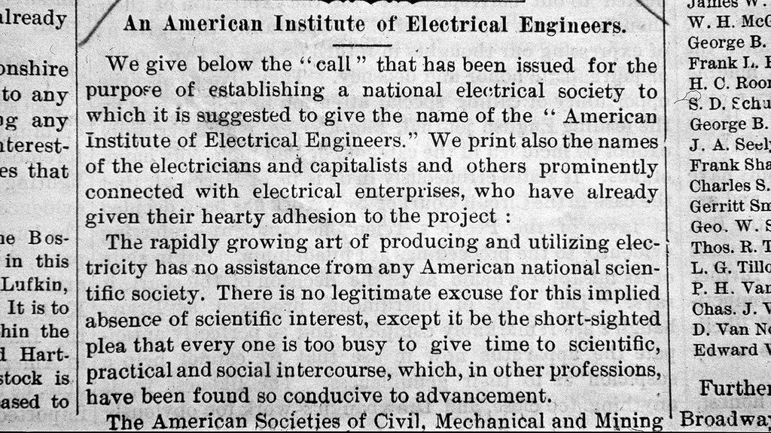
Fig. 1 – Call for establishing a national electrical society “American Institute of Electrical Engineers” - АIEE, published in “Electrical World”, on 05.04.1884 [1]
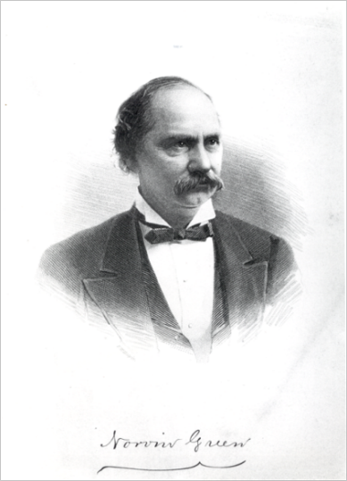

Fig. 2 – Norvin Green, the president “Western Union Telegraph” and first president of the AIEE [1]
The author of this “call” was Nathaniel Shepard Keith. As a result of this call, on May 13, 1884, a small group of individuals met in New York and founded the “American Institute of Electrical Engineers” – AIEE for short, to advance the new field and to represent the US at the 1884 “International Electrical Exhibition” in Philadelphia. Norvin Green of Western Union became the first president (Fig. 2).
That October, on October 7th and 8th, the AIEE held its first technical meeting in Philadelphia during the “International Electrical Exhibition”. Many early leaders, such as founding President Norvin Green of Western Union, came from telegraphy. Others, such as Thomas Edison, came from power, while the newer telephone industry was represented by Alexander Graham Bell.
As electric power spread rapidly across the land, enhanced by innovations, such as Nikola Tesla's AC Induction Motor, long distance AC transmission and large-scale power plants, and commercialized by industries such as Westinghouse and General Electric, the AIEE became increasingly focused on electrical power and its ability to change people's lives through the unprecedented products and services it could deliver.
There was a secondary focus on wired communication, both the telegraph and the telephone. Through technical meetings, publications, codes of ethics, and promotion of standards, the AIEE led the growth of the electrical engineering profession, while through local sections and student branches, it brought its benefits to engineers in widespread places.
The standardization was one of the very important goals of AIEE. The very first standing committee appointed by AIEE was the Committee on standards and units with Arthur E. Kennelly as its chairman. The first standard was adopted in 1893 (Fig. 3).
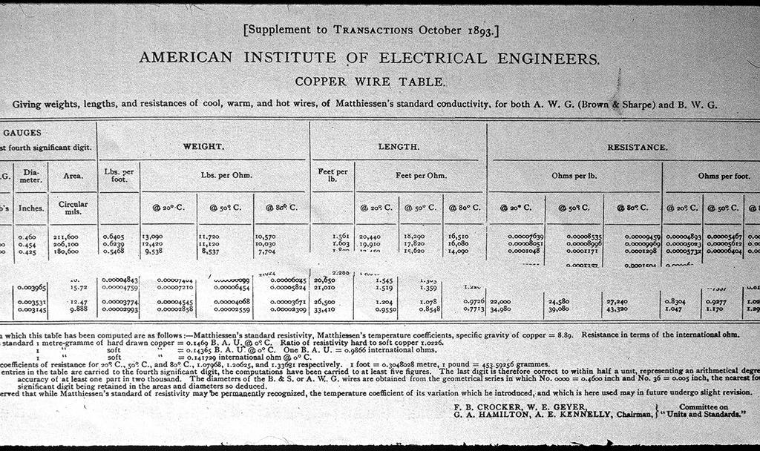
Fig. 3 – The first AIEE standard [1]
On the other hand, the AIEE was focusing its activities to disseminate the news in the profession to the engineers anywhere in the world. To help this process the local AIEE sections started to be organized. The first AIEE local sections we organized in US (Chicago and Ithaca Sections – 1902). The first section outside of US was established in Toronto, Canada, in 1903.
On March 8, 1912, the Board of Directors of the AIEE adopted “The Code of Principles of Professional Conduct of the AIEE” (Fig. 4), defining the basic principles of conduct of engineers within their profession. This kind of document exists today and is known as “Code of Ethics” of the IEEE. In 1909 a Student Branch of AIEE was formed at Cornell. In 1930, AIEE formed a Geographical District Executive Committee.
In the period from its foundation (1884) until 1963 (merging with IRE to form the IEEE) among the presidents of the AIEE were: Alexander Graham Bell (1891-92), Charles P. Steinmetz (1901-02), Michael I. Pupin (1925-26) etc.
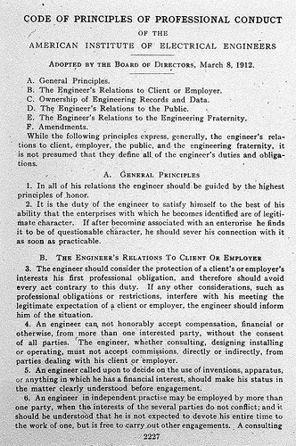
Fig. 4 – AIEE “Code of Conduct” from 1912 [1]

FORMATION OF THE IRE [1], [2], [3], [4]
Radio, a new electrical technology, arose in the first decade of the twentieth century. Wireless telegraphy using spark transmitters was the original application. But, it began to be used to transmit speech and music, after the invention of the vacuum tube amplifier, made possible by the inventions of the vacuum tube diode (John Fleming - 1904) and the vacuum tube triode (Lee de Forest - 1907), all of them based on thermionic emission - Frederick Guthrie, 1873.
The evolution of the new industry initiated the birth of a new society, the Institute of Radio Engineers (IRE), in 1912. The IRE was modeled on the AIEE, but was devoted to radio, and then increasingly to electronics. In the same way as the AIEE, the IRE served its members and their professions by running technical conferences, publishing journals (Fig. 5), promulgating standards, developing codes of ethics, encouraging its members to advance their industries by promoting innovation and excellence in the emerging new products and services, and encouraging the training of student engineers.
Robert H. Marriott was elected as the first president of the IRE in 1912. From 1912 until 1963 among the IRE presidents were: Michael I. Pupin (1917), Frederick E. Terman (1941), William R. Hewlett (1954) and many others.
Members of the IRE became many distinguished radio and electronics engineers, but also the distinguished electrical engineers already members of the AIEE.
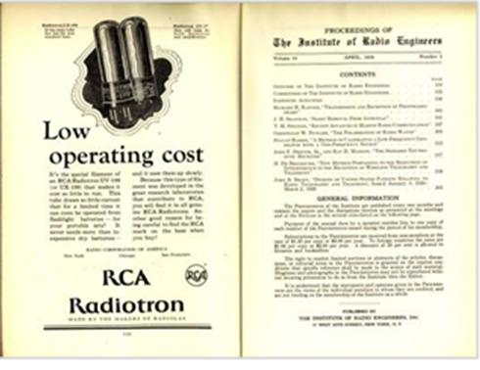
Fig. 5 – “Proceedings of the IRE”, September 1926 issue [1]
Among the AIEE and IRE members Michael I. Pupin and Arthur E. Kennelly were presidents of both societies in different periods. Fig 6 was taken at the IRE 1915 annual banquet held in New York. Nikola Tesla can be seen among the participants.
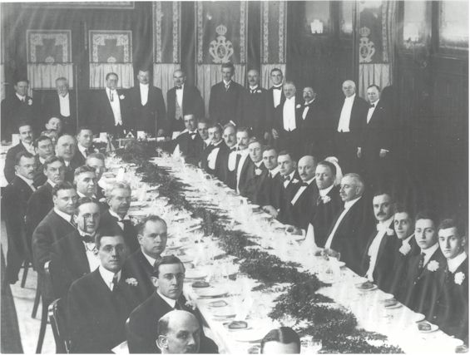
Fig. 6 – From the IRE annual banquet, New York 1915 [1]. Nikola Tesla is standing (6-th from the left)

FOUNDATION OF IЕЕE [1], [2], [3], [4]
The two societies and their members play a leading role in the development of the industry. Through the applications of its members' innovations to industry, electricity wove its way deeply and deeply into every corner of life: television, radar, transistors, computers became the consumer goods. The interests of the societies more and more overlapped. Membership in both societies grew, but beginning in the 1940s, as a result of much faster development of radio and electronics engineering, the IRE grew faster and in 1957 became the larger group (Fig.7).
The idea of merging the two societies in one, common for all electrical and electronics engineers, was not new, but it became more actual as the professions expanded beyond their separate roots in power and radio. The special issue of the “Proceedings of the IRE” dedicated to the merging of the two societies was published in March 1962 [4]. Finally, in 1962, the boards and memberships of the two institutes agreed to merge.
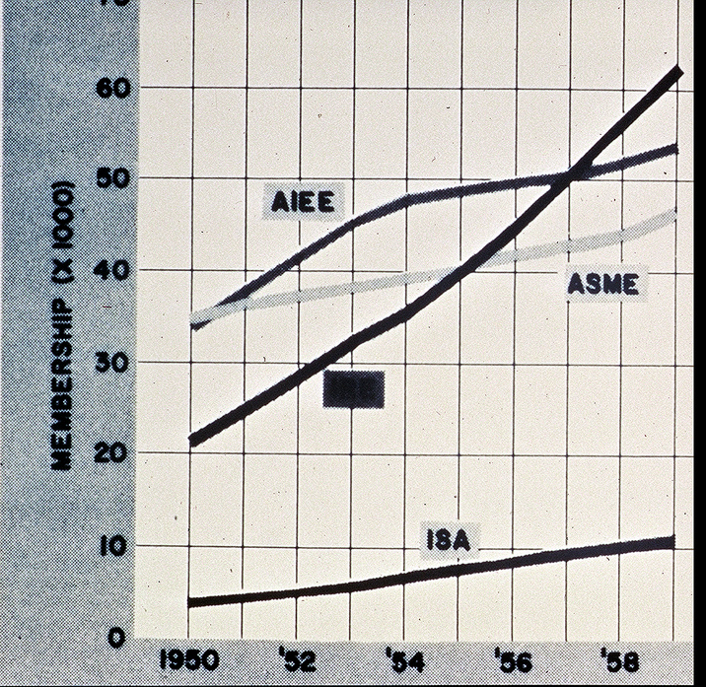
IRE

Fig. 7 – Membership growth of engineering societies (including AIEE and IRE) between 1950 and 1959 [1]

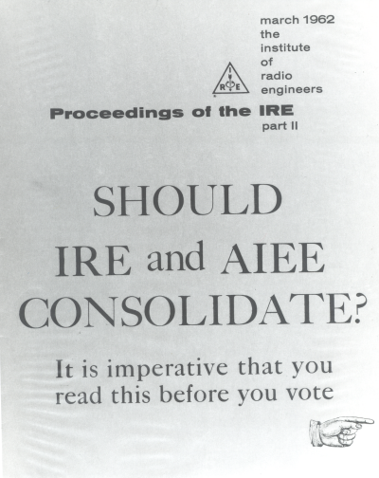
Fig. 8 – Special issue of the “Proceedings of the IRE” dedicated to the merging of the AIEE and IRE into one society [4]
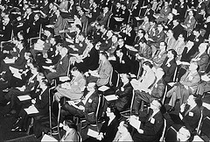
Fig. 9 – The convention of the IRE in 1962 on proposed AIEE/IRE merging
On 1 January 1963, The AIEE and the IRE merged to form the Institute of Electrical and Electronics Engineers, or IEEE. At its formation, the IEEE had 150,000 members, 140,000 of whom were in the United States. As the first president of IEEE was elected the 1959 IRE president, Ernst Weber.

THE HISTORY OF IЕЕE LOGO [5], [6]
The first AIEE logo, or member badge, (Fig. 10-а) was adopted in 1893 after three years of discussion during which various designs were offered by a committee headed by Dr. Alexander Graham Bell, President of AIEE in 1891-1892. Its outline represented Franklin's kite. Its periphery was marked by an actual coil of gold wire with mid-points spanned by a galvanometer complete with blued steel needle and covered by an amber disc in the way to embody the Wheatstone bridge. The letters AIEE were imprinted in the upper triangle, while in the bottom triangle the Ohm's law was written, to support this remarkable condensation of the history of electrical science. It was abandoned after four years. In 1897, AIEE adopted the logo (Fig.10-b) which served essentially unchanged until the merger of 1963.
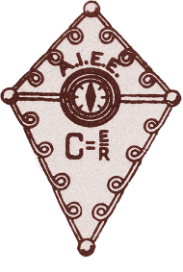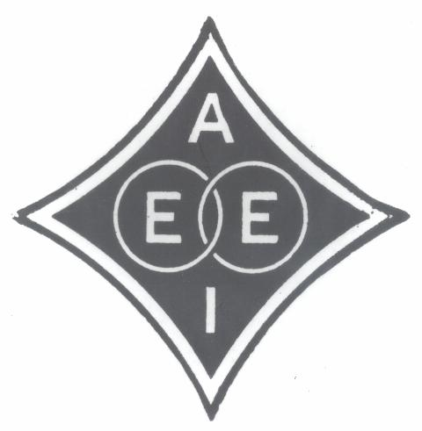
(а) (b)
Fig. 10 – а) The first AIEE logo, adopted 1893; b) the modified AIEE logo, adopted 1897 [1]
Here the central theme is the linked circles representing the relation of the electric and magnetic fields. The symmetrical outline approximates a hypocycloid of four cusps. It may still suggest a kite and a bridge, but in any event it provides for a balanced distribution of the four initials of the society.
The IRE, founded in 1912, as a consolidation of The Society of Wireless Telegraph Engineers and The Wireless Institute, chose the triangle and arrows representing electrical and magnetic forces in the conventional "right-hand rule" relationship (Fig. 11). In choosing as its logo this fundamental concept, IRE rejected the designs of its predecessor organizations, SWTE and TWI, both of which had used as their insignia the Hertz oscillator and receiver loop. However, currently important or historically significant, specific techniques or equipment were wisely judged inadequate symbols for a dynamic organization. The triangular outline of the IRE emblem also provided for a balanced display of three initials.
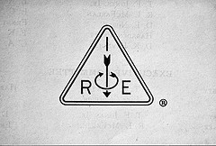
Fig. 11 – The IRE logo adopted in 1912 [1]
The IEEE logo evolved rationally from its predecessors and retains in its outline and central device readily recognizable features of each. Representing an organization formed by the consolidation of AIEE and IRE, the logo of IEEE derives its design from the insignia of the two constituents. However, it is not a mere compound of these two components. Rather, it continues the trend toward an emphasis of basic concepts characteristic not only of the evolution of the logos of the constituent organizations, but of the whole electrical engineering education and practice.
Both the logos, of IRE and AIEE, had as a central motif the association of electricity and magnetism, perhaps the most fundamental concept lending itself to graphical representation. In one case, two arrows represent current and magneto motive force. In the other, linked circles suggest the relation of the electric and magnetic fields.
The use of the right-hand rule in the IEEE logo captures, in simplistic terms, the great mathematical foundations of the profession. The right-hand rule is symbolic of the mathematical relationship between the electric and magnetic fields [6]. It serves as a reminder that electrical engineering and the technologies that flow from it are based on the calculus and higher orders of mathematics as would be expected of a learned profession.
In a similar manner the kite, as found in the original logo of the AIEE, represents the kite used by Benjamin Franklin when he discovered electricity in lightning. So the kite immortalizes discovery as an essential element of the engineering profession. The IEEE kite logo is shown without the tail and in a symmetrical diamond form. The geometry of diamond shaped kite with its right-hand rule can also be viewed as a stylized form of the Wheatstone bridge.
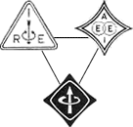
Fig. 12 –The new IEEE logo was a combination of the logos of the IRE and the AIEE [5]
The IEEE logo today is based on the logo adopted in 1963, but it includes, also, the four letters defining the name of the organization (Fig. 13).

Fig. 13 – The IEEE logo today
For the IEEE’s 125th Anniversary a special logo has been presented (Fig.14)

Fig. 14 – The IEEE’s 125th Anniversary logo.

THE IEEE GROWTH AND GLOBALIZATION
The new institution began to develop very rapidly. The IEEE started programs to raise the visibility of its technologies, but also to become a professional in addition to a technical institution to better serve its members. Over the decades that followed IEEE continued to spread across the world. The professional groups and technical boards of the predecessor institutions evolved into IEEE Societies to serve the needs of its various communities.
Since that time, computers evolved from massive mainframes to desktop appliances to portable devices, all part of a global network connected by satellites and then by fiber optics. IEEE's fields of interest expanded well beyond electrical/electronic engineering and computing into areas such as micro- and nanotechnology, ultrasonic, bioengineering, robotics, electronic materials, and many others. As technologies and the industries that developed them increasingly transcended national boundaries, IEEE became a truly global institution which used the innovations of the practitioners it represented in order to enhance its own excellence in delivering products and services to members, industries, and the public at large.
Publications and educational programs were delivered online, as were member services such as renewal and elections. By 2008, IEEE had 375,000 members in 160 countries, with 45 percent outside of the country where it was founded a century and a quarter before. By the early 21st Century, IEEE served its members and their interests with 38 societies; 130 journals, transactions and magazines; more 300 conferences annually; and 900 active standards.
Through its worldwide network of geographical units, publications, web services, and conferences, IEEE remains the world's leading professional association for the advancement of technology.
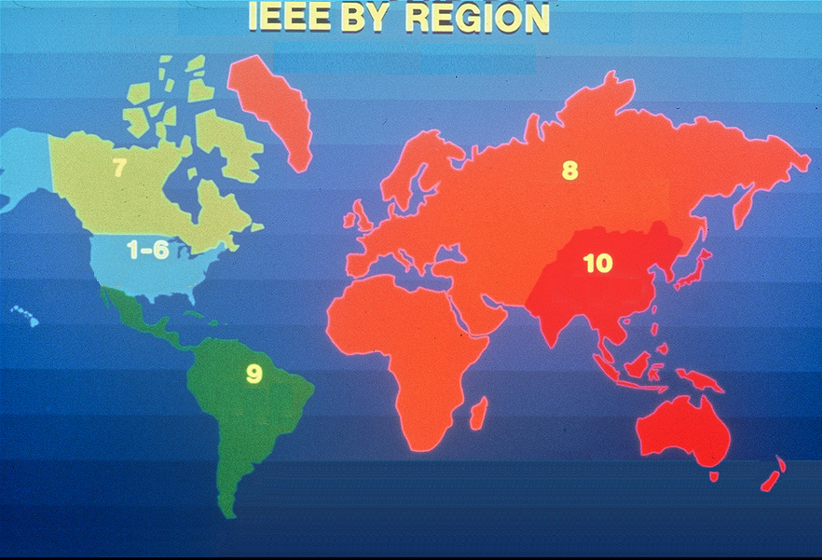
Fig. 15 – The IEEE by regions
Today IEEE is the world leading professional organization with:
- More than 375,000 members, including nearly 80,000 student members in more than 160 countries;
- 324 sections in ten geographic regions worldwide (Fig. 15);
- 1,784 chapters that unite local members with similar technical interests;
- 1,616 student branches and 452 student branch chapters at colleges and universities in 80 countries;
- 38 societies and 7 technical councils representing the wide range of technical interests;
- 390 affinity groups consisting of Consultants' Network, Graduates of the Last Decade (GOLD), Women in Engineering (WIE) and Life Members (LM) groups;
- Nearly 1,300 standards and projects under development;
- Nearly 2 million documents in the IEEE Xplore®digital library;
- 144 published transactions, journals and magazines;
- More than 850 sponsored conferences annually.
Up to date 20 IEEE members are Nobel prize winner: 18 for physics, 1 for medicine and 1 for economy.

IЕЕE IN FORMER YUGOSLAVIA
7.1. IEEE Yugoslav Section
IEEE has been present in former Socialist Federal Republic of Yugoslavia (SFRY), by individual membership since beginning of 60s. In 1971 a critical number of members have been reached and petition has been submitted to form a section. It was finally approved on June 21, 1971 and the section was formed in Ljubljana and named IEEE Yugoslav Section. Most of the members were from main university centers, Ljubljana (now in Slovenia), Zagreb (now in Croatia) and Belgrade (now in Serbia). The first chair was Mirjan Gruden (1910-2001) professor at the University of Ljubljana. At that time activities were mainly focus on organization of the meetings and some conferences. The main goals of membership were to get access to the most recent journals and other publications and conference proceedings. As it is today, the financial problems were emphasized. Toni Davis in his history of the IEEE Region 8 Committee recalls: “Because of a ‘blocked currency’ situation, USA, but an arrangement was made to keep the funds in Yugoslavia where they could be utilized for organization of local IEEE conferences and also could be used to pay the local costs of conference attendance there by visitors from Western countries, who could then reimburse IEEE in USA.” [8]. However, despite this hurdles the activities in the section were flourishing. Several society chapters were formed, like SP01/CAS04 Chapter in 1988, MTT17 in 1989, COM19 in 1989 and ED15/SSC37 Chapter in 1990. Some of nowadays well known conferences have been established in the section, while some IEEE R8 conferences were hosted, like IEEE MELECON Conference on May 1991 in Ljubljana (now Slovenia).

7.2 Friendly splitting of IEEE Yugoslav Section
The turmoil in SFRY and separation of Slovenia and Croatia in 1991 has put in question existence of IEEE Yugoslav Section.
In 1992 the Regional Director Prof. Kurt Richter invited the Chair of the IEEE Yugoslav Section Prof. Baldomir Zajc from Ljubljana and the two members of the Section Committee, Prof. Djordje (George) Paunovic from Belgrade and Prof. Aleksandar Szabo from Zagreb to Graz, Austria. The unanimous conclusion of that meeting in Graz was that the IEEE Yugoslav Section cannot practically exist anymore, and that new sections in new countries having enough members should be established.
So in Slovenia, Croatia and the remainder of Yugoslavia new petitions have been signed by members, and on 1st August 1992 new Sections, the successors of the former Yugoslav Section, have been established: the IEEE Slovenia Section, the IEEE Croatia Section and the IEEE Yugoslavia Section. IEEE recognized all the years the three Sections spent together in the former IEEE Yugoslav Section as years of our existence as well. So in Helsinki at the IEEE Region 8 Committee Meeting in 1996 all three sections received the banner for the 25 years anniversary of existence.
The first chair of the IEEE Yugoslavia Section, which covered the remaining territory of former SFRY (Bosnia & Herzegovina, Macedonia, Serbia and Montenegro) was Prof. George Paunović from the University of Belgrade.
7.3. Birth of new sections
Unfortunate events and fragmentation of SFRY Yugoslavia continued so it was impossible to organize IEEE member activities on the remaining territory. New independent countries emerged from SFRY in 1991 and 1992, beside Slovenia and Croatia, were looking for their recognition in IEEE community as well. In 1997 on the 14th February colleagues from Skopje managed to gather the membership and establish the IEEE section in Macedonia under name the IEEE Republic of Macedonia Section. The first section chair was Prof. Goce Arsov form SS Cyril and Methodius University of Skopje.
In 2005, on November 12, members from Bosnia and Herzegovina got approved their petition to form the IEEE Bosnia and Herzegovina Section in Sarajevo. The first chair was Prof. Branislava Peruničić-Draženović from University of Sarajevo.
At the same time the name of the section became obsolete and was replaced with IEEE Serbia and Montenegro Section, which covered the territory of the State Union of Serbia and Montenegro. After secession of the Montenegro in May 2006, the section remains to work under the same name, but gathering members from two independent states: Republic of Serbia and Republic of Montenegro. The chair of the section from 2002 - 2006 was Prof. Ninoslav Stojadinović from University of Niš. He was followed by Prof. Vladimir Katić from University of Novi Sad, who was re-elected in 2008 (2006-2008-2010).
7.4 Ex-Yugoslav sections today
Today, in 2009, from initial IEEE Yugoslav Section, five sections were formed: IEEE Bosnia and Herzegovina Section, IEEE Croatia Section, IEEE Republic of Macedonia Section, IEEE Slovenia Section and IEEE Serbia and Montenegro Section. Table 1 gives short overview of the sections history.
Table 1 – Short history of IEEE in former Yugoslavia
21st June 1971 | Foundation date of the IEEE Yugoslav Section. At that time IEEE Yugoslav Section covered the territory of the former Socialist Federal Republic of Yugoslavia (SFRY).
1st August 1992 | Friendly splitting of the IEEE Yugoslav Section into three different sections: IEEE Croatia Section, IEEE Slovenia Section and IEEE Yugoslavia Section. After that date the IEEE Yugoslavia Section gathered members from the territories of the three independent states: Bosnia & Herzegovina, Macedonia and FR Yugoslavia (Serbia & Montenegro)
14th February 1997 | Formation of the IEEE Republic of Macedonia Section. After that date IEEE Yugoslavia Section gathered members from the territories of the two states: Bosnia & Herzegovina and FR Yugoslavia (Serbia & Montenegro)
18th June 2005 | IEEE Yugoslavia Section changed the name into the IEEE Serbia & Montenegro Section, as the state union Serbia and Montenegro has been formed in 2003, replacing FR Yugoslavia
12th November 2005 | Foundation of the IEEE Bosnia and Herzegovina Section. From that date membership of the IEEE Serbia & Montenegro Section came from the territory of the state union Serbia and Montenegro, only.
21st May 2006 | Since that day IEEE Serbia & Montenegro Section gathered members from the territories of the two independent states, Republic of Serbia and Republic of Montenegro.
These sections have very live activities with numerous meetings, conferences, lectures, professional, technical, social and other events. The overview of the ex-Yugoslav sections is given in Table 2. According to SAMIEEE database in 2008, they gathered in total 1785 members in all grades [9]. Nowadays, they represent important part of IEEE community and are much emphasized, especially in IEEE Region 8.
The most important thing is that these sections communicate very frequently and collaborate in many events on regional and international levels. The mutual support and help is also characteristic of their relation, leading to constant membership growth and further development for the benefit of their members.
Table 2 - Overview of ex-Yugoslav sections (2008)
IEEE Section name | No. of members (2008) | No. of chapters + affinity groups | No. of meetings  (2008)
Bosnia and Herzegovina | 178 | 4 + 1 | 19
Croatia | 645 | 18 + 2 | 53
Rep. of Macedonia | 118 | 7 + 1 | 34
Serbia and Montenegro | 566 | 9 + 1 | 96
Slovenia | 278 | 5 + 0 | 23

ACKNOLEDGEMENT
The authors wish to thank IEEE for providing available on the web, enough material, making this paper possible.

REFERENCES
- www.ieee125.org
- ****, IEEE’s 125th Anniversary: “A Brief History of IEEE”, www.ieee125.org/about/history.htm
- Harlow Freitag, Editor: “Electrical Engineering – The Second Century Begins”, IEEE PRESS, Piscataway, USA, 1986.
- IEEE Global History Network: www.ieeeghn.org
- The IEEE Emblem, IEEE Student Journal, March 1963, pp 48. (www.ieee.org/web/aboutus/history_center/ieee_ emblem.html)
- W. Cleon Anderson: History and Significance of the IEEE Logo, IEEE Magnetics Society Newsletter, Vol. 37 No. 1, Jan. 2000
- www.ieee.uns.ac.rs
- http://ewh.ieee.org/reg/8/cms/index.php
- www.ieee.org/samieee

