Geometric interpretation of the beta factor in special relativity
by Phillips V. Bradford, Sc.D.
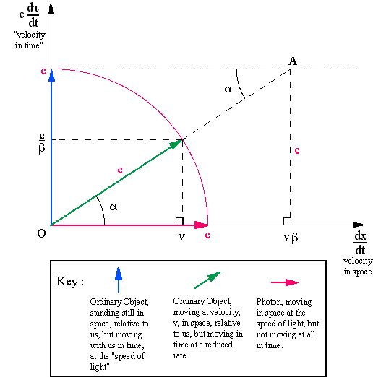

The idea here is that all forms of matter and energy are always traveling at the speed of light. The computer in front of you, the coffee mug (if you have one), and all the other things around you are traveling with you in time. We are all going from an earlier time to a later time (perhaps it is going from 3:00 p.m. to 4:00 p.m. right now!). The rate at which we are traveling through time is uniform and inexorable, it is the speed of light. We cannot reduce or advance its speed, nor can we fall behind or jump ahead to an earlier or later time. In the geometric diagram above, the horizontal axis is velocity in space, and the vertical axis is "velocity" in time. The time velocity is rationalized as in the Minkowski co-ordinates of four-dimensional geometry, where, in the drawing above, the vertical axis is cdt/d(tau) where tau is time in an inertial reference frame that measures time as an imaginary length representing a difference in time between some event and "now", but both at the same place. Here, as in many treatments, tau is the so-called "proper time", a number representing time as it might appear in a "history" relative to an arbitrary rest frame of reference. Proper time, tau is usually represented by the the Greek letter, tau, as in the diagram above. c is the speed of light. Numbers in the plane are real on the horizontal axis and complex elsewhere in the plane, with the units of i> along the vertical axis where i is the "imaginary" number unit (the square root of minus one). Geometric measurements in the complex plane are seen a ordinary plane geometry. The idea that we are in "motion" through time is captured by the expression, cdt /d(tau) = c, representing a rate of the passage of time, which is always, c, the speed of light for stationary objects.
The vertical blue arrow along the vertical axis represents an object, such as a coffee mug, that has no spatial velocity with respect to us (i.e. no component along the horizontal axis). It is seen traveling at the speed of light through time (along with us).
The horizontal red arrow along the horizontal axis is a photon, traveling through space at the speed of light, but standing still in time with respect to us (i.e. it has no component along the vertical axis).
The diagonal green arrow is representative of an object moving at a high velocity, v, more than 80% of the speed of light, c, in space (on the horizontal axis) with respect to us. Green arrows can occur for real objects with a non-zero rest mass at any angle, alpha, greater than zero, up to and including 90 degrees. In principle, green arrows can point in any direction except, 0 and 180 degrees, the negative horizontal and vertical axes should be mirror images of their positive counterparts. Note that magnitude of the green arrow, including components on both axes, is also the speed of light, delimited by the circle in red, which terminates the green arrow.
Now, from simple geometry we find:
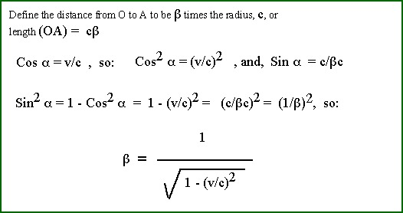

This treatment shows that the "beta" factor so commonly found in special relativity, can be easily derived with simple geometry.

Possible Significance
The idea that all things always travel at the speed of light in Minkowski space-time, has several possible implications. First, it provides some heuristic comfort in the idea that mass has an enormous "hidden" (i.e. atomic) energy in the form of E = mc^2.
Another possible significance is that an object in motion seems to rotate its velocity vector in space-time, maintaining a constant magnitude at the speed of light, c, as it changes velocity, v. A rotation in space-time is perfectly smooth with variations in velocity, except for transitions to the horizontal axis, where there seems to be a singularity. Changing a green arrow into a red arrow, and vice-versa, requires quantum-mechanical processes, usually accompanied by what appears to us as "violence" requiring collisions and high energy processes. When atomic particles collide, some of their their mass somehow turns into energy in the form of photons, and makes a [quantum?] jump to the horizontal axis. Likewise, there is experimental evidence that photons, for example, can be absorbed on various materials to form electron-positron pairs, showing that a [quantum?] process can rotate photons (red arrows) from the horizontal axis to objects at various angles on the diagram (green arrows). One can visualize that a small part of the mass of the fissionable material in a nuclear bomb at rest makes a sudden right angle turn from moving through time to moving through space in the form of photons and other light-speed items, such as neutrinos.
In gravitational fields and other accelerative processes, masses undergo smooth rotations in space-time as they change their velocity during free-fall. As an object approaches a black hole, however, the rotation of space-time must broach the singularity of the horizontal axis and mass cannot fall into it without acquiring apparently infinite energy, or waiting forever. It would appear that mass must be converted to photons before it can enter a black hole.
Speculation on space-time rotation phenomena might lead to alternative models in cosmology. Perhaps there is a cosmological rotation of space-time, each quarter-turn taking about 15 billion years. Perhaps the "big bang" is an illusion created by such a rotation, and both the Hubble red shift and the microwave relict radiation are residues of a process that moves long-distance photons into lower energy photons, perhaps "spinning off" thermal microwaves as the horizontal line in the diagram slowly rotates.
The idea that no material object can move faster than the speed of light in a vacuum meets with resistance in some alternative physics treatments. The idea presented here, however, places a much more stringent condition on the velocity of material objects. In the complex space of time and distance, the complex magnitude of the velocity of a material object can neither exceed nor be less than the speed of light in a vacuum. It can only equal the speed of light!

Background References
For a discussion of the feasibility of using complex numbers (numbers which have real and imaginary parts) to describe four-dimensional space, see Relativity - the Special and General Theory, by Albert Einstein, published by Crown Publishers, Inc., 1961. There is on page 121, an Appendix II entitled: Minkowski’s Four-Dimensional Space ("World").
Hermann Minkowski (1864-1909), a German Professor of mathematics, born in Russia, developed a number system that seems appropriate for describing co-ordinates in a four-dimensional space-time continuum. In his approach, we may think of events in space-time that occur at a particular place and at a particular time. The place is defined by three ordinary x, y, and z, spatial co-ordinates, in some frame of reference, and the time is defined by an "imaginary" coordinate, ict, where <i is the [imaginary] square root of minus 1, (-1); c is the speed of light, and t is time, measured in an arbitrary frame of reference.
If we think of an event as a flash bulb popping off at some place and time, this event can be described by four such numbers, x1, y1, z1, and ict1. If there is another flash bulb popping off in another place and time, x2, y2, z2, and ict2; we can define the "interval" between these two events by simple Pythagorean law. The interval is the square root of the sum of the squares of the "distances": x2 - x1, y2 - y1, z2 - z1, and ic (t2 - t1). Note that the "distance" ic (t2 - t1) is "imaginary" but is in units of distance. The product of a unit of velocity, such as the speed of light, c, and a unit of time, is a unit of distance. As an imaginary distance, however, its square will be a negative real number. Therefore, the interval between events in space-time is the square root of the sum of four terms, three of which are always positive, and one of which is always negative.
After selecting a common frame of reference, if the two flash bulbs flash at the same time, but in different places, the interval will be a positive real number. On the other hand, if both bulbs are in the same place, but flash at different times, the interval will be the square root of a negative real number, or an imaginary number. The interval between the two events is zero if the three positive terms equal the negative term. This is equivalent to saying that the interval between two events is zero if they can be connected by a beam of light. Suppose the second flashbulb was triggered to pop when it was struck by the light of the first bulb. Then they are said to flash simultaneously, because the interval between their flashes is zero.
In the Special Theory of Relativity, the interval between events is independent of the choice of the common reference frame in which the distances and time between the events is measured. We may select a reference frame that recognizes x = y = z = t = 0 where and when the first flash bulb pops. Then we can measure the values of x, y, z, and t when and where the second flash bulb pops. We can also orient the direction of the three spatial co-ordinates, so that the flash of the second bulb is along the x-direction, so that y = z = 0. In this reference frame the interval between the two flashes is then the square root of the sum of the values of x squared and - (ct) squared. The diagram above has reduced the spatial co-ordinates to one, in the x-direction, and shows the vertical axis as the imaginary time dimension. The field of the diagram is thus the conventional complex number field, and the red circle proscribes the velocity dependent nature of time (t) with respect to tau.
Since the interval between two events is the same in all inertial reference frames, it is known as an invariant. Thus, we can write: x^2 - c^2*t^2 = x’^2 - c^2*t’^2 = - c^2*(tau)^2, where tau is used for the time co-ordinate in a reference frame that places both events at the same place (i.e. x = 0. Using x^2 - c^2*t^2 = -c^2*(tau)^2, we may divide both sides of this equation by -c^2*(tau)^2 and replace (x / (tau))^2</b> by <b>(x / t)^2*(t / (tau))^2, then use x / t = v, to get the expression t = (tau)(beta). This algebraic treatment was shown to me by Dr. Lester Seigel of Alexandria, VA.

